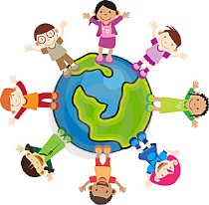 **Cultural Patterns and Diffusion** 

**An Introduction to Culture**

**Geography Standard Three 6-8a:** Students will identify and explain the major cultural patterns of human activity in the world’s sub-regions.

What makes a place culturally unique?

* What is culture?
* How might site and situation affect the development of a culture?
* How does culture affect the nature of a place?
* Under what conditions do cultures spread?
* What happens to places when people to trade and travel?
* Why do people move? How does immigration change places?
* What spatial patterns develop when cultures develop and diffuse?

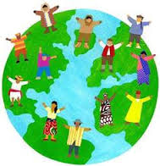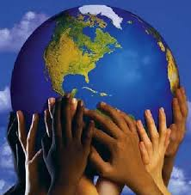

**Student Resource Packet**

**Fall 2014**

**Name:___________________________**

**Period: ___**

Geography Standard 3A: Mrs. Bole

**Civilizations & Cultural Hearths…**From Nomad to Civilizations.

Lesson 2

Before you read, what comes to mind when you hear the word CIVILIZATION? _________________________________

__________________________________________________________________________________________________

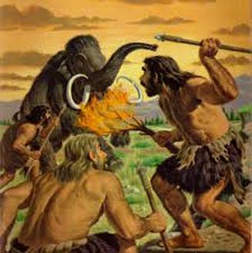For most of human existence, people lived in a desperate time where there wasn't enough food to feed everyone all the time. They were always trying to hunt enough food and gather enough food to feed themselves each day. They lived day to day securing the food needed to survive. They had to be constantly on the move, following the animals they hunted and looking for new, fresh, vegetation to pick. As a result of their nomadic lives, they could only have the barest of material possessions.

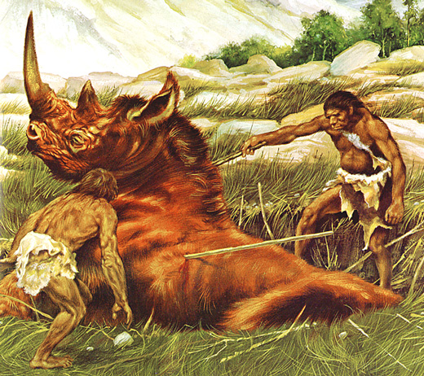Hunter and gather tribes had to be very small (usually 20-30 people). Their way of life could not support an excess population because they couldn't feed more than 20-30 people. Because of their constant need to secure food, hunters and gatherers could not devote energy to do anything else but hunt and gather. **They lived a life of scarcity and want.** This way of life continued unchanged for over two million years. Then, in fertile river valleys, human beings learned how to plant seeds (**agriculture**) and tame animals (**domestication**). They learned how to farm. This slow transition from hunting to gathering is known as the Agricultural Revolution.

The **Agricultural Revolution** (farming) changed every aspect of their lives. It was much better than hunting and gathering for securing food. It was so successful that they were actually able to produce a **surplus** of food. For the first time in human history humans produced food to be able to take care of not only today's meals but tomorrow's as well. Because so much more food could now be grown and harvested the population exploded! Farming's success made it possible for some of those people to direct their energies to things other than getting food. Some could become artisans, creating possessions that people could now enjoy because they had given up their nomadic lives and stayed in one place. Some of the population could now be priests or scribes. Others could learn how to build great architectural structures or serve in a military meant to protect the people of the civilization.

The success of farming meant that there would be enough food to support this new **specialization** in jobs. For the first time ever, human energy could be used to do things other than look for food to survive. Because they were now planting crops and farming animals, they could settle down with their 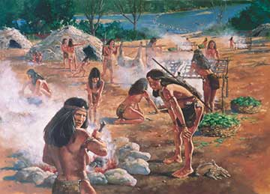families and settlements could emerge eventually leading to cities. Once this began, civilizations would develop along with it laws and written language to name a few.

*Define the following terms: scarcity, agriculture, domestication, Agricultural Revolution, surplus, specialization*

1. How did nomads live? __________________________________________________

__________________________________________________________________

2. Why did nomads travel in groups no larger than 20-30 people? ___________________

_______________________________________________________________________

3. In the passage it states that nomads... "lived a life of scarcity and want." Explain what that means. ______________________________________________________________

_______________________________________________________________________

4. What is the Agricultural Revolution? _______________________________________

_______________________________________________________________________

5. How did the Agricultural Revolution change life for man? (List at least two things.) ___

______________________________________________________________________________________________________________________________________________

6. Why did the Agricultural Revolution cause a population explosion? ________________

_______________________________________________________________________

7. What happened when civilizations developed? ________________________________

**Thinking Like a Historian**

**Directions: Read the Background Essay and complete the information below. You will need a highlighter and a pencil.**

|  |
| --- |
| **Read paragraphs 1-7 and answer the questions.** |
| Vocabulary: Pilgrim defines the ODDs and Turkeys define the Even  **1.Prehistory: _____________________________________________________________________**  **2Archeology:_____________________________________________________________________**  **3.Nomads: _______________________________________________________________________**  **4.Emerge: _______________________________________________________________________**  **5.Paleolithic People:_______________________________________________________________**  **6.Customs: ______________________________________________________________________**  What happened 5,000 years ago?_________________ What CAUSED it to happen? ______________________  How do we KNOW how Paleolithic people lived? _______________________________________________  Highlight this information in the text. |
| **Read paragraphs 8 & 9 and answer the questions.** |
| Vocabulary: Define…  **7.Neolithic Age:__________________________________________________________________**  What **CHANGED** during the Neolithic Age? ___________________________________________________  Who **BENEFITED** from this change? _______________________________________________________  Compare & Contrast:   |  |  | | --- | --- | | Paleolithic People | Neolithic People | |  |  | |
| Read paragraph 10. |
| Vocabulary: Define…  **8.Accumulate:____________________________________________________________________**  WHAT IS IT?  Time Period where man learned to farm.  Explain the Neolithic Period on a separate piece of paper.    Creation of  1)_____________  2)_____________  Accumulation of:  **EFFECTS OF SETTLING DOWN**  Need to develop new ___________ |

**What are Civilizations?**An advanced society (group of people) that has made progress in the arts and sciences, keeps records, writes, has a complex system of political and social institutions. They follow laws, has some type of religion and has a system to provide food for a large quantity of people.

Summary: 40,000 years ago man was ________________. 10,000 years ago man discovered ______________________________. Agriculture lead to __________________ societies. Agriculture created permanent ______________, living together in greater numbers. Shift from complex societies to civilizations took a very long ________. Farming created a whole new way of _________.

Modern humans appeared about 40,000 years ago. They lived successfully in small nomadic hunting/gathering bands until about 10,000 years ago when agriculture began to replace hunting and gathering as the dominant way of life.

The rise of agriculture allowed for the development of more complex societies. The change to agriculture was a critical trigger for the development of more complex societies since it allowed people to establish permanent settlements and live together in far greater numbers than ever before.

The shift toward agriculture happened gradually over a long period of time, independently on all continents, except Australia. For the vast majority of history, humans lived as hunters and gatherers. The emergence of farming resulted in a whole new way of living. By producing food more systematically, humans were able to live together in greater numbers and greater density than ever before. But such growth in population also required new ways of social organization. As cities grew and influenced human settlements near and far, what developed has come to be known as civilization.

Agricultural Revolution Video

Please watch the video and fill in the blanks in the frames below. They go in order! Then, in the square above the box please draw a picture to represent the phrase in the box below it.

What caused the development of civilizations (cities?)

**Pease place this information on your Steps to Civilization Worksheet.**

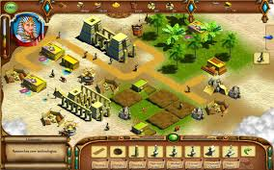

*40,000 years ago man first walked this earth

 *They were nomads

 *They hunted and gathered food following the food each season.

 *Because this way of life did not provide a lot of food nomads lived in small groups UNTIL...

*10,000 years ago man began learning how to farm and it replaced hunting and gathering

*This slow transition to farming (known as the AGRICULTURAL REVOLUTION) forced man to stay   
in one location so they could tend to their crops.

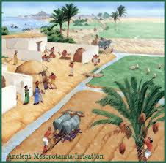 *They could now produce MORE food than ever before.

 *More food led to more people living together in these settlements

 *This led to the birth of civilization (cities).

 *More people living together created a need for some form of Social Structure...laws,

government etc... *Gradually Cultural Hearths were born!

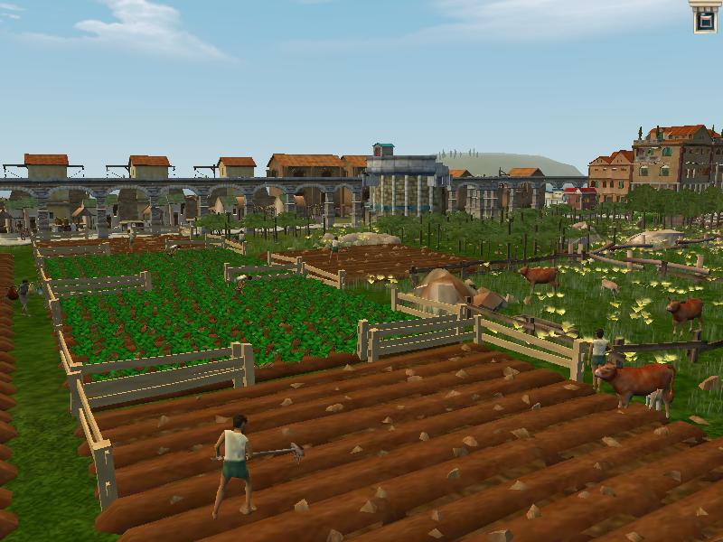

Eight Features of Civilization

**Cities:**

As farmers settled in fertile river valleys, they began to grow surplus or extra food. This extra food increased the population of the settlements. In time, the settlements grew into cities, such as Ur in Sumer or Babylon in Mesopotamia.

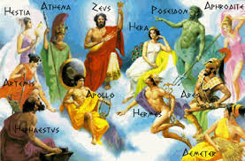**Complex Religions:**

Religious leaders would conduct elaborate ceremonies to appease the gods (polytheism) and insure a bountiful harvest. Floods and droughts were blamed on the gods’ anger so rituals were conducted in the temples.

**Social Classes:**

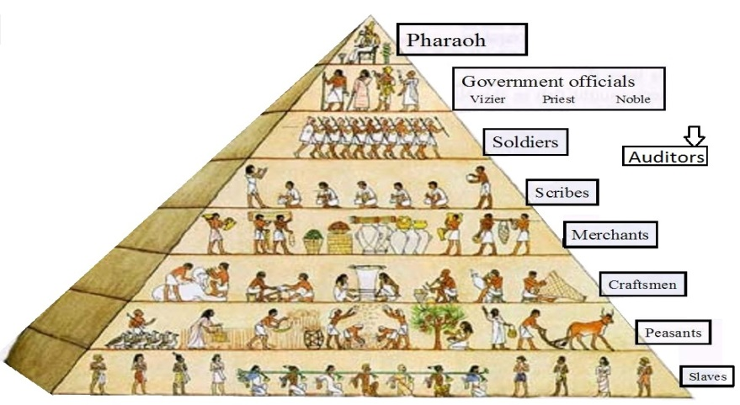As jobs became specialized so did the status and needs of certain individuals. The need for a knowledgeable and educated religious leader was more respected than an unskilled worker. Herders were needed and respected for the food, while masons were needed for building. The slave was on the lowest rung of the social ladder warriors and kings were on top.

**Art and Architecture:**

This expressed the beliefs and values of a civilization. Different styles were developed

and copied by societies. Often the art was used to impress visitors and people about the beauty and power of a king or a community.

**Organized Central Governments:**

As cities developed and expanded, the food supply and irrigation systems needed to be

maintained. Governments, such as councils or religious leaders, began to oversee the business and existence of the cities.

**Job Specialization:**

As civilizations became more complex, artisans and craftsmen were needed to maintain

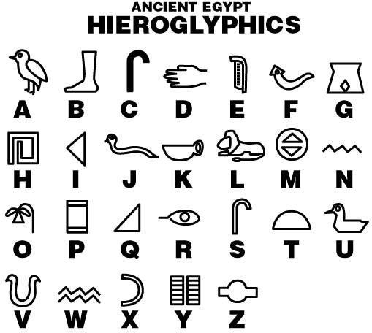specific items and tasks. No longer could individuals do all the work. Now some concentrated on teaching.

**Writing:**

Records were needed to keep accounts on trade goods and food storage. Writing was needed because the information became too great. In addition, one needed to express more complex ideas such as "belief" and "social order" where pictures and words simply would not suffice.

**Public Works:**

The government would order these, although costly, to aid and benefit the community. Such things as a wall to protect from attack or a canal to aid in irrigation would help insure the survival of a people.

Civilizations: Is it a Civilization? Or NOT?

**Directions:** Read the scenarios below and complete the table on the next page.

**1.** The ancient Egyptians controlled the area around the Nile River valley. Their capital city was Alexandria. Other important cities were Memphis, Thebes, and Tanis. They worshipped many gods and were united under one ruler who was called a pharaoh. Ancient Egypt had three main social classes. The upper class consisted of the royal family, rich landowners, government officials, high-ranking priests, army officers, and doctors who often wore ornate jewelry. The middle class was made up primarily of merchants and craft workers. The lower class consisted of unskilled laborers. The best-known achievements of the ancient Egyptians are the mathematically ingenuous pyramids built as tombs for their rulers. The ancient Egyptians invented a form of picture writing

known as hieroglyphics.

**2.** During the summer a group of Neanderthals camped in the Neander Valley in the area known as Germany. This community was ruled by the strongest male member of the group who determined the status of other members and who controlled the distribution of food. Women gathered nuts, berries, and roots while the men hunted game with a variety of stone tools and wooden spears.

The elderly cared for the young children and passed on the traditions of the group by telling stories. The members of the group lived in caves and used fire to stay warm, to cook, and to dry their food. There is evidence that they practiced a form of religion, and they buried their dead.

**3.** Early settlers in Mesopotamia developed farming communities primarily between the Tigris and Euphrates Rivers. The early settlers located originally in this area because the rivers were a source of food and fresh water for both people and animals. Trade between the communities was established because they could travel and transport goods easily on water. In addition to providing a source of food and water, the rivers also presented a challenge to these early settlers. They had to learn to control the floodwaters so they could farm, and they needed ways to store water for the dry periods. This required leadership, cooperation, and planning. Community meetings and leaders began to emerge to direct and plan irrigation and flood control. The prestige and power of families varied and from the more powerful ones emerged the leaders. Records of crops and livestock were kept by the use of colored rocks. Mesopotamians carved ornate figures and objects into stone, which were used to communicate stories and events. A writing system known as cuneiform was developed in

which wedges were impressed with clay and a stylus.

**4.** The Zipidoites had long been a nomadic people made up of many different large families. In recent years, they had developed permanent settlements including homes, buildings, warehouses, factories, schools, and churches. They discovered that by developing permanent settlements, only a small percentage of people had to devote their time to food production. The rest would then

develop other skills such as trading and bartering, designing weapons and tools, crafting jewelry and clothing, and various professional skills. The Zipidoites were a peace-loving group of people. There had been no conflicts with neighboring groups for many years. There had been virtually no conflicts

between members of their community for so long they had abandoned the council who ran each family. They made many advancements and contributed their success to their ability to build dams, aqueducts, and canals to irrigate their crops.

**5.** The Aztecs built an impressive city at the present site of Mexico City. They were a resourceful people who developed a calendar, a spoken language, and a form of writing called pictographic writing. They produced various forms of oral literature and were accomplished artists and craft workers. Agriculture formed the basis of the Aztec economy, and corn was the most important crop.

The market place was a major center of Aztec life. Warfare was considered a religious duty. The highest goal for a young man was to be a successful warrior. Men who took many captives in battle received land, high social rank, and held important government offices

**6**. The Incas can be characterized as methodical, highly organized, and intensive data collectors. They ruled one of the largest and richest empires in the Americas. Inca emperors ruled their large empire through a complex political system. All commoners paid taxes by doing work for the government and by giving the government a portion of their crops, livestock, or fish. They were

skilled in engineering and crafts, as is evidenced by the network of roads that connected the vast empire and the ornate articles created from gold, silver, and other materials. They studied the stars and planets and used their observations to predict the seasons. They performed mathematical calculations that they used in designing buildings and roads. They built four main roads that came

out of Cusco, their capital city. Religion played and important role in the private and public lives of all Incas. Official records and folk stories were kept by “rememberers” who used a system called “quipo” – a cord with knotted strings of various lengths and colors that was used to record information.

**7.** The Sumerians were an ancient people who lived in a region in southern Mesopotamia. The Sumerians built their city-states around the large, brick temples called ziggurats. Around the base of the ziggurats were homes for the priests and shops for the artisans who made everything from pottery to weapons. The fertile lands around the cities were made productive with an extensive network of dams and irrigation canals. The ancient Sumerians lived by a code of law designed and enforced by its government officials. These laws, the most famous of which are called the Code of Hammurabi, were recorded on baked clay tablets. The laws show many inequities in the social structure.

Nobles and priests were punished less severely than common people, and women had fewer rights than men.

**8.** A spacecraft lands on a distant planet and finds a group of people who are living in cities that are more beautiful than any on Earth. There is a planetary government, and there has not been a war there in anyone’s memory. No one works or goes to school because all of the work is done by robots. The robots are so efficient they even repair themselves. There is a universal language spoken by all of the people. All written documents are completed by the robots whose internal computers translate all verbal information from the inhabitants to written information. Though there are rules and regulations, there is little to no crime because everything is provided and no one does without anything. Their greatest fear is that the robots will eventually wear out, and they continuously pray to their gods to deliver them from this possible disaster.

**Read each scenario and while reading place a "C:\Documents and Settings\sherri.bole\Local Settings\Temporary Internet Files\Content.IE5\6PMLZM5U\MC900441310[1].png in the appropriate square if that element of civilization is present.**

|  |  |  |  |  |  |  |  |  |
| --- | --- | --- | --- | --- | --- | --- | --- | --- |
| Scenario | Writing | Public Works | Government/  Laws | Art/  Architecture | Social  Classes | Organized  Religion | Job  Specialization | Cities |
| 1 |  |  |  |  |  |  |  |  |
| 2 |  |  |  |  |  |  |  |  |
| 3 |  |  |  |  |  |  |  |  |
| 4 |  |  |  |  |  |  |  |  |
| 5 |  |  |  |  |  |  |  |  |
| 6 |  |  |  |  |  |  |  |  |
| 7 |  |  |  |  |  |  |  |  |
| 8 |  |  |  |  |  |  |  |  |

The Birth of Cultural Hearths (Ancient and Modern)

**Cultural Hearths: Where would you think cultures would develop? Along ________________________.**

***Cultural hearths*** are places where a unique cultural cluster of language, customs, and other traits developed.

* In the ancient past, major cultures began in an area called a **cultural hearth**. From these areas, cultures spread (diffused) outward, carried by people involved in trade, travel, conquest or immigration. Geographers and historians believe that there were several cultural hearths in the ancient world. They are shown on the map below.
* In each of these cultural hearths, people developed a different way of doing things like eating, building shelter, speaking, writing, and making a living, and living together. For example, in the Chinese Wei-Huang Valley, people ate rice with chopsticks, spoke Chinese language, wrote with pictographs, and developed a respect for ancestors.

**Cultural Hearths in History**

* In seven places known today, ancient people “invented” cultures, and these cultures still influence the way people live today. The seven original cultural hearths are located in: Mesopotamia, Nile Valley and the Indus Valley, Wei-Huang Valley, Ganges Valley, Mesoamerica, West Africa, Andean America. Locate each cultural hearth on the map.
* The hearth is the CORE, or the center, where the culture began.

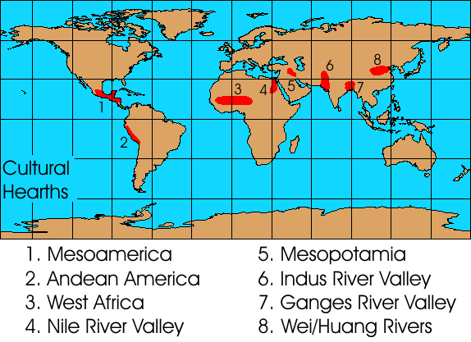

**The seven original culture hearths are:**

1)The Nile River Valley  
2) The ________ River Valley  
3) The Wei-Huang Valley  
4) The _______ River Valley  
5) Mesopotamia  
6) _________________  
7) West __________

**Cultural regions** are based on one or more aspects of human culture. They are functional regions; that is, they are based on *activities of people living in the area*. **Religion** and **language** are two common cultural characteristics used to determine cultural regions. Geographers use real, observable data to locate the region. They may use census records, the locations of churches or temples, or the language used in schools or business advertising to determine *where* a language is spoken or a religion is followed. Because people move around as a part of daily life, the boundaries of cultural regions may change over time.



**Check for Understanding:**

Why did ancient civilizations appear in these locations? What makes these ancient sites so unique?_______________________________

What features did Mesopotamia (#5) have that would make this a great area to live in? __________________________________________________________________________________________________________________________________________________________________________________

Each of these represent a ___________of a culture. These are the original cultural hearths because these groups were the first civilizations that “invented” __________________.

**A closer look at cultural regions**

**Core:** The part of the region where the cultural traits are found most often.

* **Periphery:** The part of the region where cultural traits are found less frequently.
* On the map to the right, the dark green area circled in red represents the core of the cultural region. In this area, almost everyone followed all of the cultural ways of doing. The light green area circled in blue is called the periphery. In this area, most people followed the ways of the culture at least most of the time, but other languages, belief systems, ways of eating, or making a living might also be seen there occasionally. In the area outside the region (yellow on the map) people would not follow the cultural pattern.

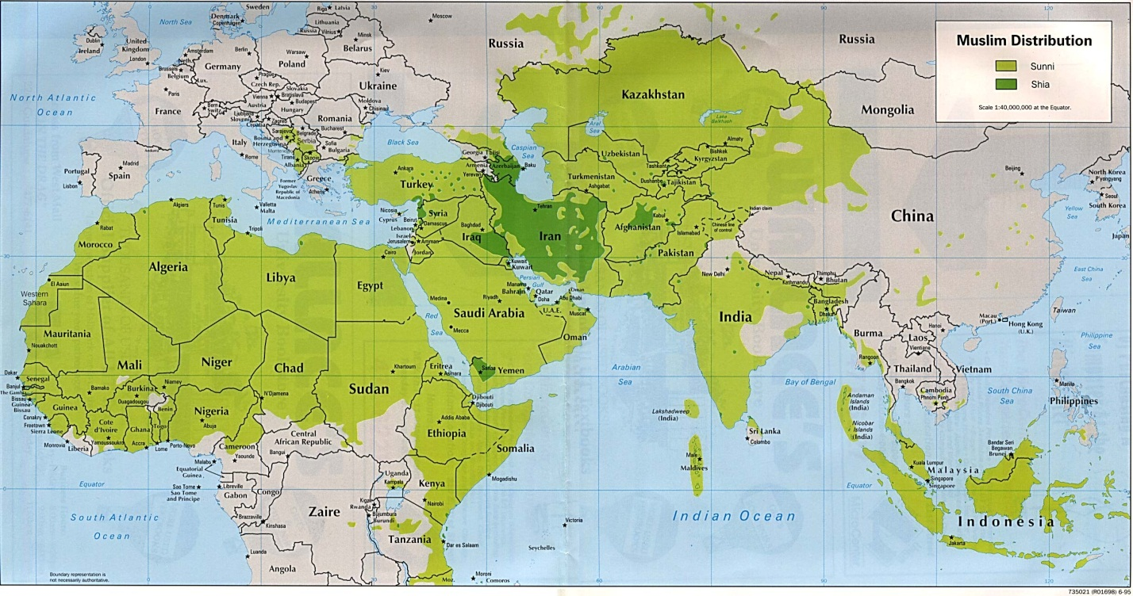

**Check for Understanding: How are cultural regions determined?** ___________________________________ _________________________________________________________________________________________

**Cultural Diffusion**

Diffusion takes place people from the core share their unique cultural ideas with people in new areas.

Cultural diffusion is the term used to describe the spread of cultural ideas from the Core (in the case of culture regions) and the culture. Whenever people travel, they carry their culture with them. For this reason, culture spreads fastest along travel routes. Places with many connections are likely to receive visitors from many cultures, and their ideas (dress styles, language and religion, knowledge about inventions, all kinds of things!) shape the place. On the other hand, places with few connections are less affected by other cultures. They change very slowly.

Because cultures develop over time, new dominant areas of dominant culture have done so as well. Today's modern culture hearths are places such as the United States and [world cities](http://geography.about.com/od/worldcities/Largest_Cities_of_the_World.htm) like London and Tokyo.

**Check for Understanding:**

Areas in the world that are closest to _________________ will have the most cultural diffusion. **Draw 5 gold stars** in locations that you feel would have very diverse cultures and **3 red Xs** where cultures might have little diversity.

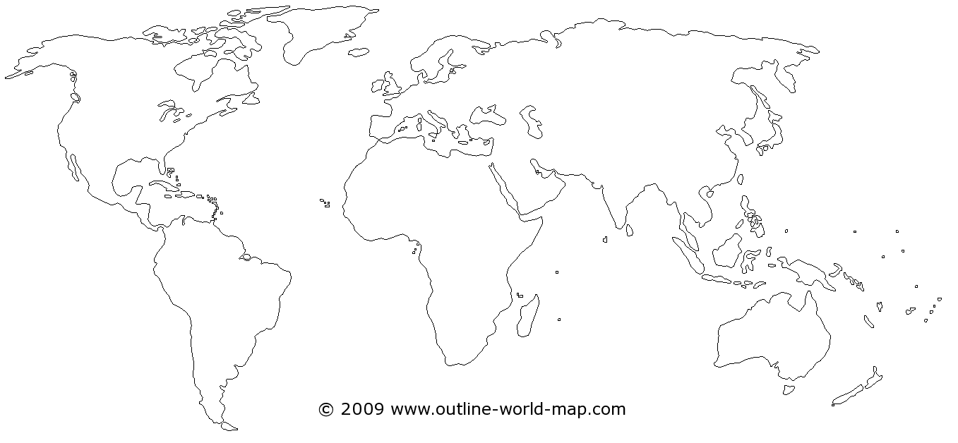

**Check for Understanding:**

Somewhere in America his afternoon, a child is suiting up for his after-school Karate class. Somewhere in China, a teen girl is leaving for a concert dressed in American blue jeans and T-shirt.

How might a geographer explain these choices? ______________________________________________________________________________________________________________________________________________________________________________________________

What is Culture?

Lesson 1

**__________________ (Heading) **

The term Western culture has come to define the culture of European countries as well as those such as the United States that have been heavily influenced by European immigration. Western culture has its roots in the Classical Period of the Greco-Roman era and the rise of Christianity in the 14th century. Other drivers of the Western culture include Latin, Celtic, Germanic and Hellenic ethnic and linguistic groups. Today, the influences of Western culture can be seen in almost every country in the world.

**__________________ (Heading)**

Eastern culture generally refers to the societal norms of countries in Far East Asia (including China, Japan, Vietnam, North Korea and South Korea) and the Indian subcontinent. Like the West, Eastern culture was heavily influenced by religion during its early development. In general, in Eastern culture there is less of a distinction between secular society and religious philosophy than there is in

the West.

**__________________ (Heading)** 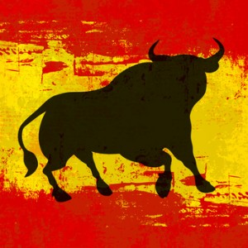

Many of the Spanish-speaking nations are considered part of the Latin culture, while the geographic region is widespread. Latin America is typically defined as those parts of the Central America, South America and Mexico where Spanish or Portuguese are the dominant languages. While Spain and Portugal are on the European continent, they are considered the key influencers of what is known as Latin culture, which denotes people using languages derived from Latin, also known as Romance languages.

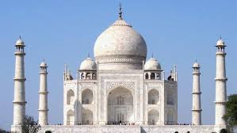**__________________ (Heading)**

The countries of the Middle East have some but not all things in common, including a strong belief in Islam and religion is a very strong pillar of this society. The Arabic language is also common throughout the region; however, the wide variety of dialect can sometimes make communication difficult.

The continent of Africa is essential two cultures — North Africa and Sub-Saharan Africa. The continent is comprised of a number of tribes, ethnic and social groups. One of the key features of this culture is the large number of ethnic groups — some countries can have 20 or more — and the diversity of their beliefs Northwest Africa in particular has strong ties to European and Southwestern Asia. The area also has a heavy Islamic influence and is a major player in the Arab world. The harsh environment has been a large factor in the development of Sub-Saharan Africa culture, as there are a number of languages, cuisines, art and musical styles that have sprung up among the far-flung populations.

**Think.Pair.Share.**How are cultures different? How are they similar? Highlight information in the text to support your answer. **_________________________________________________________________________________________________________________________________________________________________________________________________________________________________________________________**

**______________________________________________________________________________________________________________________________________________________________________**

Read the quote below and based on the information you just read on the previous page, explain what the author means. (You may need to look up words you don’t know in the dictionary.)

***“Appreciation of our differences starts with the acknowledgment of our similarities.”***

-Peter Reese

____________________________________________________________________________________________________________________________________________________________________________________________________________________________________________________________________________________________________________________________________________________________________________________________________________________________________________________________________________________________________________________________________________________________________________________________________________

**Think About It.**

Based on the information you have read so far…Do you think we have more in common or are do we have more differences? Explain using evidence from the text.

__________________________________________________________________________________________________________________________________________________________________________________________________________________________________________________________________________________________________________________________________________________________________________________________________________________________________________________________________________________________________________________________________________________________________

What Is Culture? Continued…

Culture is what you learn as you grow up. Culture includes what you know about how to speak and act toward others. Your culture celebrates certain holidays and not others, teaches you certain things and not others. For example, you might celebrate the 4th of July, but in other places, it’s just another day in the month. Parts of a culture include what you eat, wear, what kind of place you live – the houses and neighborhoods.

Look at the pictures below and answer the questions that follow.

1) What individual is being shown in each picture? ________________________________________

2) What commonalities do you see? (What do they have in COMMON?) ________________________

______________________________________________________________________________

3) Are they different in any way? Explain. ______________________________________________

______________________________________________________________________________4) WHY do you think they are different? Explain. ________________________________________

____________________________________________________________________________________________________________________________________________________________

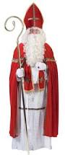 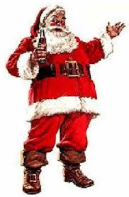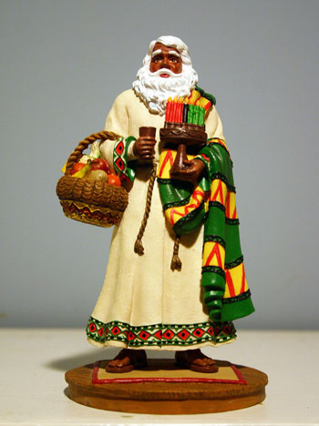 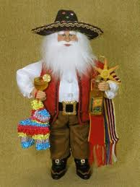

**Think.Pair.Share**

From the text, what makes a place **culturally unique**? How do you know that?

______________________________________________________________________________________________________________________________________________

Site & Situation and its Effects on Culture

BEFORE you read…VOCAB

Accessibility: ____________________________________________________________

Isolation: _______________________________________________________________

The study of settlement patterns is one of the most important aspects of urban geography. Settlements can range in size from a small village with a few hundred residents to a metropolitan city of over one million people. Geographers often study the reasons behind why such cities develop where they do and what factors lead to their becoming a large city over time or remaining as a small village. Some of the reasons behind these patterns are thought of in terms of the area's site and its situation - two of the most important concepts in the study of urban geography.

**What is Site?**

**Site** is the characteristics of that place. (What is there?) Things such as climate (weather), soil (dirt,clay, mud), landforms (mountains, lakes, deserts) , vegetation (plants) and buildings/landmarks. Historically, these factors led to the development of major cities worldwide. New York City, for example, is located where it is because of several site factors. As people arrived in North America from Europe, they began to settle in this area because it was a coastal location with a **natural** **harbor**. There was also an abundance of fresh water in the nearby Hudson River and small creeks as well as raw materials for building supplies. In addition, the nearby Appalachian and Catskill Mountains provided a barrier to movement inland.

**SITE** also contains PEOPLE with cultural attributes who **modify** (change) the environment to create a

unique place. The site of an area can also create challenges for its population and the small Himalayan

nation of Bhutan is a good example of this. Located within the world's highest mountain range, the

terrain of the country is extremely rugged and hard to get around. This, combined with the incredibly harsh

climate in many areas of the country has made much of the population settle along rivers in the highlands

just south of the Himalayas. In addition, only 2% of the land in the nation is arable (with much of it located

in the highlands) making living in the country highly challenging.

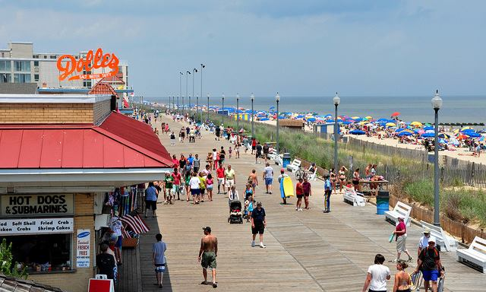

**Look at the picture of Rehoboth Beach. Describe its SITE. ________________________________________________**

**What is Situation?**

**Situation**

Situation is defined as the location of a place relative to its surroundings and other places. Factors included in an area's situation include the accessibility of the location (how **EASY** it is to go in and out of the region), the extent of a place's connections with another (can it reach other places easily), and how close an area may be to raw materials if they are not located specifically on the site. Though its site has made living in the nation challenging, Bhutan's situation has allowed it to maintain its policies of isolation as well as its own highly separated and traditionally religious culture. Situation is the SITE'S location in relationship to other places around it. How close is the site to other things? Is it close to other sites? Places close together have more interaction and it is easier for these sites to  Trade,  Travel, and share information. Places farther away do not get to trade, travel and share information as easily.

**Below is a map of the Delmarva Region. The arrow is pointing to Rehoboth Beach, Delaware. Describe its SITUATION.**

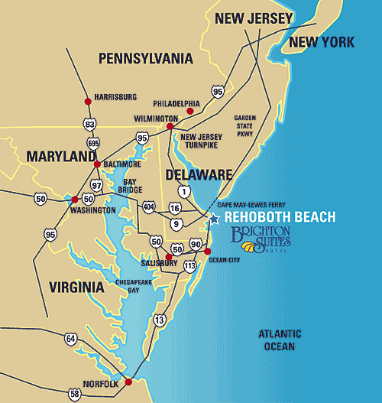

______________________________________________________________________________

______________________________________________________________________________

______________________________________________________________________________

______________________________________________________________________________

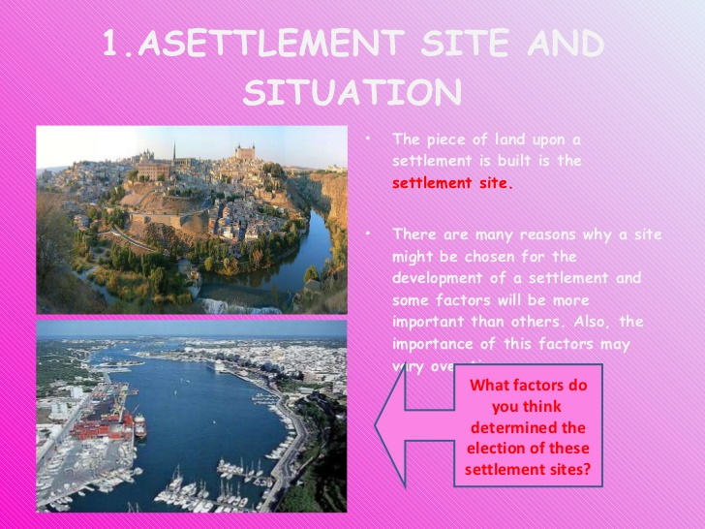Think About It Activity

1) What are two factors that determine where people settle?

* _____________________________________________________________________________________
* _____________________________________________________________________________________

2) How can Site pose problems to people who live in a particular region? Cite specific evidence from the

text to support your answer. Highlight the information in the text.

____________________________________________________________________________________________________________________________________________________________________________________________________________________________________________________________________________________________________

|  |  |
| --- | --- |
| **Characteristics of Site** | **Characteristics of Situation** |
|  |  |

Site & Situation Activity

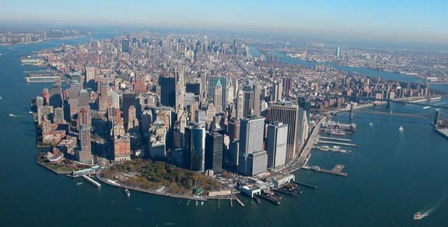Based on the information you learned about Site & Situation, complete the activities below.

Describe the SITE of the picture to the right.

___________________________________

___________________________________

___________________________________

Can you name this SITE? _______________

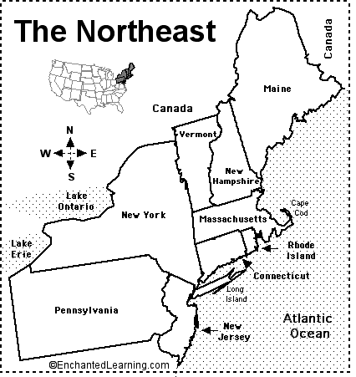

Describe the SITUATION of New York City. In

other words, how ACCESSIBLE is it to other places? ________________________________

______________________________________

______________________________________

______________________________________

______________________________________

______________________________________

Site & Situation…Continued

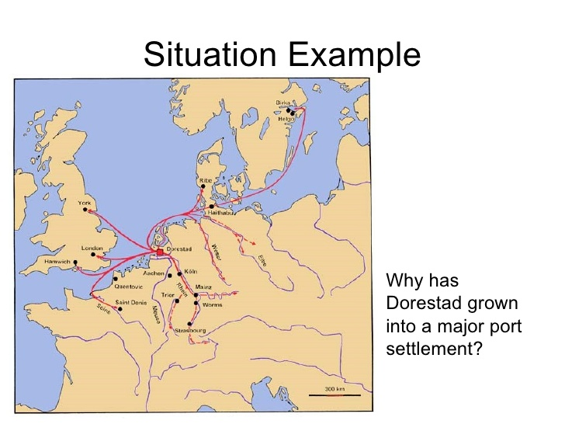 **Look at the pictures and decide if it's a good example of site or situation. Write the word Site or Situation over the picture.**

The map to the left shows trade routes from Dorestad. Based on what you know about Site & Situation, why has Dorestad grown into a major port settlement?__________

__________________________________________________________________________________________________________________________________________________________________________________________________________________________________________________________________________________________________________________________________

**Dorestad**

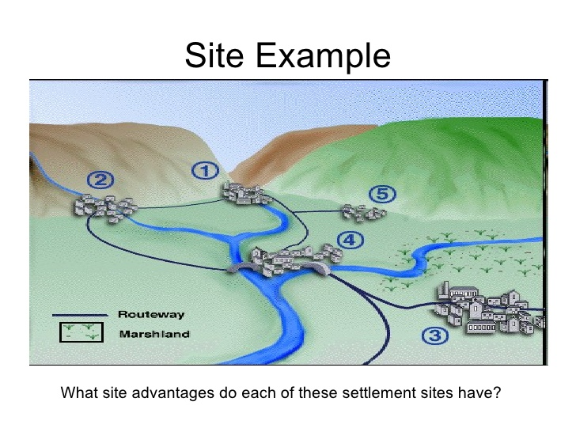

__________________________________________________________________________________________________________________________________________________________________________________________________________________________________________________________________________________________________________________________________________________________________________________________________________________________________________________________________________________________________________________________________________________________________________________________________________________________

Cultural Diffusion

Before you read…

What do you think the word Cultural Diffusion means? _____________________________________________________

__________________________________________________________________________________________________

***Cultural diffusion*** concerns the spread of culture and the factors that account for it, such as migration, travel/communications, trade, and commerce. Because culture moves over space, the geography of culture is constantly changing. Generally, culture traits originate in a particular area and spread outward, ultimately to characterize a larger expanse of territory. *Culture region* describes the location of culture traits or cultural communities; *cultural diffusion* helps explain how they got there.

For example, New York State generally lies within the English-speaking culture region. Nevertheless there are significant cultural communities within New York State in which Spanish, Chinese, Hebrew, Arabic, or another language is dominant. Similarly, while most of New York State is part of the Christian culture region, there also are local cultural communities in which Judaism, Islam, or Buddhism is dominant. What all these languages and religions have in common is that none originated in New York State or even in North America. Rather, each has come to characterize segments of the Empire State as a result of cultural diffusion.

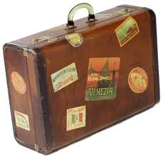**Explain how this suite case represents cultural diffusion.**

1. What is Cultural Diffusion?
2. What are four factors that make it possible for cultures to spread? Highlight in the text where you found the information.

**_________________________________________**

**_________________________________________**

**_________________________________________**

**_________________________________________**

Cultural Diffusion Has Its Limits

**Think About It**

The Americas were inhabited by natives centuries before Europeans began colonizing the region. If man existed on the continents of Europe and Asia much sooner, why did it take them so long to colonize the Americas?   
(Highlight information from the text to support your answer.)

____________________________________________________________________________________________________________________________________________________________________________

When a cultural item diffuses, it typically does not keep spreading and spreading forever. Instead it tends to diffuse outward from its place of origin, encounter one or more *barrier effects*—things that inhibit cultural diffusion—and stop spreading. Barrier effects can assume physical or social forms. *Physical barrier effects* consist of characteristics of the natural (physical) environment that inhibit the spread of culture. The classic examples are oceans, deserts, mountain ranges, dense forests, and frigid climates. For example, the Atlantic Ocean was a physical barrier that prevented the westward spread of European culture for many centuries. The dense rain forest of the Amazon lowlands long served as a physical barrier, isolating numerous native peoples and their ancient ways of life. While some of these groups have recently experienced culture change wrought by roads and deforestation, others continue to lead traditional lives in remote regions of rainforest. Similarly, the rugged Andes Mountains have long served to inhibit diffusion of foreign culture throughout that region, thus helping to perpetuate indigenous cultural characteristics. One result is that Quechua (pronounced KAY-chew-ah), purportedly the language of the Incas, continues to be spoken by millions of Andean residents.

1. When cultures diffuse, does it continue to spread forever? _______ Explain. ___________ _______________________________________________________________________

2. What is a *barrier effect*? _________________________________________________ _______________________________________________________________________

3. List five examples of physical barriers to cultural diffusion. a)__________________ b)__________________c)____________________ d)__________________ e)__________________

Types of Cultural Diffusion

Different aspects of culture, such as ideas, religious & political ideologies, innovations & technologies, and patterns of behavior are spread from one area of the world to another. This occurs through a process known as **cultural diffusion.** Thanks to the practice of trade, cultures are usually not isolated from each other. Consequently, cultural diffusion has been responsible for the advancement of civilization.   
  
There are a few **cultural hearths** around the globe, source areas from which the world's major cultures, ideologies, and innovations spread. Examples of culture hearths are the Nile Valley in Egypt and Mesopotamia. Innovations in agriculture and irrigation diffused outward from Mesopotamia. Egypt was a source for great artistry and engineering, as evidenced by the pyramids.   
  
There are three forms of cultural diffusion:

* **Direct diffusion** is when two cultures are very close to each other, resulting in intermarriage, trade, and even warfare. An example of direct diffusion is between the United States and Canada, where the people living on the border of these two countries engage in hockey (a sport that started in Canada), and baseball, which is big in America.
* **Forced diffusion** occurs when one culture subjugates (conquers or enslaves) another culture and forces its own customs on the conquered people. When the Spanish came to the new world, the conquistadors took over the indigenous (native) population and forced them to practice Christianity.
* **Indirect diffusion** happens when traits are passed from one culture through a middleman without the first and final cultures ever being in direct contact. An example would be the presence of Mexican food in Canada, since they have a huge country in between them.

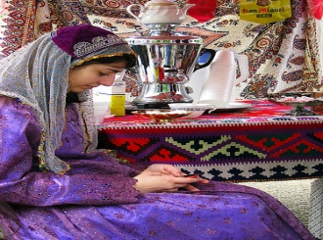  
Direct diffusion was very common in ancient times when small groups or bands of humans lived in adjoining settlements. Indirect diffusion is very common in today's world. Today, the prevalence of indirect diffusion is because of the mass media and the internet.

This photo of a Turkish immigrant at a fair in Mississippi, shows direct diffusion of culture. She retains her traditional dress, but has adapted to the technology available in the United States. Image courtesy of [rogersmith/Flickr](http://www.flickr.com/photos/rogersmith/).

**Types of Cultural Diffusion**

Directions: Read the information on the handout and complete the chart below.

|  |  |  |
| --- | --- | --- |
| **Type of Diffusion** | **Explanation** | **Example** |
| **1)** |  |  |
| **2)** |  |  |
| **3)** |  |  |

**Lizzie's Morning**

**Directions: Read about Lizzie’s morning and complete the chart that follows.**

7 a.m. The clock **radio** blasts [Jamaican](http://plasma.nationalgeographic.com/mapmachine/index.html?id=362&size=medium&left=-80.89&bottom=15.77&right=-73.69&top=20.45) reggae into Lizzie's room in Washington, D.C., and the music wakes her. As she comes to life, she thinks about school and the day ahead. She doesn't think about Guglielmo Marconi of [Italy](http://plasma.nationalgeographic.com/mapmachine/index.html?id=362&size=medium&left=4.55&bottom=36.65&right=20.58&top=47.09) , who patented the radio. And she doesn't know that the first experimental **radio broadcast took** place in [Massachusetts](http://plasma.nationalgeographic.com/mapmachine/index.html?id=150&size=medium&left=-75.32&bottom=39.73&right=-68.12&top=44.41) in 1906.

Lizzie gets dressed, heads to the kitchen, and makes a pitcher of orange juice, using **frozen concentrate** that was preserved by a process developed in [Florida](http://plasma.nationalgeographic.com/mapmachine/index.html?id=150&size=medium&left=-88.79&bottom=24.54&right=-78.87&top=31) during the 1940s. The very same round, golden fruit was popular in ancient [China](http://plasma.nationalgeographic.com/mapmachine/index.html?id=362&size=medium&left=73.62&bottom=15.95&right=134.77&top=55.77) .

Lizzie's mom uses an electric appliance to grind **coffee beans** from [Brazil](http://plasma.nationalgeographic.com/mapmachine/index.html?id=362&size=medium&left=-84.35&bottom=-33.74&right=-24.44&top=5.27) . The first version of this machine was invented in [Ohio](http://plasma.nationalgeographic.com/mapmachine/index.html?id=150&size=medium&left=-85.69&bottom=38.4&right=-79.65&top=42.33) in the 1930s. (Before then people used manual grinders, which date to the 1800s.) Her mom pours the ground beans into a **cone-shaped filter** invented in [Germany](http://plasma.nationalgeographic.com/mapmachine/index.html?id=362&size=medium&left=4.46&bottom=47.27&right=16.43&top=55.06) around 1900.

For breakfast, Lizzie eats a bowl of **Kellogg's corn flakes**, named after the [American](http://plasma.nationalgeographic.com/mapmachine/index.html?id=362&size=medium&left=-166.3&bottom=-8.91&right=-14.4&top=90) family that developed the cereal in the 1890s. As she eats, she glances at the newspaper. (The first regular **weekly newspapers** appeared in [Germany](http://plasma.nationalgeographic.com/mapmachine/index.html?id=362&size=medium&left=4.46&bottom=47.27&right=16.43&top=55.06) in the early 1800s.)

After breakfast, Lizzie brushes her teeth. (The Chinese claim they invented the **toothbrush** in the 1400s.) She then says good-bye to her father, who is shaving with a **safety razor**—patented in 1901 by a salesman from [Wisconsin](http://plasma.nationalgeographic.com/mapmachine/index.html?id=150&size=medium&left=-93.26&bottom=42.49&right=-85.88&top=47.3) . The earliest safety razors date from [France](http://plasma.nationalgeographic.com/mapmachine/index.html?id=362&size=medium&left=-5.09&bottom=41.36&right=9.86&top=51.09) in the late 1800s. Centuries ago, people used shells and sharks' teeth as razors.

Lizzie gathers her stuff for school, including her **saxophone**—invented in [Belgium](http://plasma.nationalgeographic.com/mapmachine/index.html?id=362&size=medium&left=.87&bottom=48.16&right=8.07&top=52.85) by Adolphe Sax in the 1840s. She puts on her **Walkman**, developed in [Japan](http://plasma.nationalgeographic.com/mapmachine/index.html?id=362&size=medium&left=118.44&bottom=24.25&right=151.05&top=45.49) in the 1970s. Then, when her mom isn't looking, she pops some **gum** into her mouth. People have enjoyed gum since ancient times, and the Indians of [Mexico](http://plasma.nationalgeographic.com/mapmachine/index.html?id=362&size=medium&left=-118.4&bottom=13.33&right=-86.74&top=33.94) and Central America chewed chicle, a substance from wild sapodilla trees. **Chicle** was introduced to the [United States](http://plasma.nationalgeographic.com/mapmachine/index.html?id=150&size=medium&left=-170&bottom=11.64&right=-66&top=79.36) in the 1860s.

Rain begins to fall as Lizzie leaves the house. She races back inside for her **umbrella**, which was made in [Taiwan](http://plasma.nationalgeographic.com/mapmachine/index.html?id=362&size=medium&left=116.54&bottom=21.26&right=123.74&top=25.95) . Umbrellas have a long past. They appear in artwork from ancient [Egypt](http://plasma.nationalgeographic.com/mapmachine/index.html?id=362&size=medium&left=23.39&bottom=21.99&right=38.22&top=31.65) , and they've been used in various cultures—both practically and ceremonially.

Back outside, Lizzie dashes across the street once the traffic light turns green. The first working **traffic signal** was installed outside the Houses of Parliament in London, the capital of the [United Kingdom](http://plasma.nationalgeographic.com/mapmachine/index.html?id=362&size=medium&left=-11.56&bottom=49.96&right=5.14&top=60.84) . Modern traffic lights were invented in the early 20th century.

The smooth, solid road that Lizzie crosses is paved with **macadam**, a surface developed in part by [English](http://plasma.nationalgeographic.com/mapmachine/index.html?id=362&size=medium&left=-11.56&bottom=49.96&right=5.14&top=60.84) engineer John McAdam. Lizzie waits a few minutes for the bus that will take her to school. The **first bus line** was established in Paris, [France](http://plasma.nationalgeographic.com/mapmachine/index.html?id=362&size=medium&left=-5.09&bottom=41.36&right=9.86&top=51.09) , in the 1600s, but it didn't last long. Not until the 1800s were horse-drawn buses a regular part of life in cities such as Paris, London, and New York.

Lizzie climbs aboard the bus, pays her fare, and heads off to school.

On a SEPARATE sheet of paper, please make three columns like the ones below and number from 1-

|  |  |  |
| --- | --- | --- |
| **Technology/Tool/Object** | **Point of Origin (s)** | **Type of Diffusion** |
|  |  |  |
|  |  |  |
|  |  |  |
|  |  |  |

**Reference Pages/Homework Assignments**



**Name:_______________________________________________**

**Fall 2014**

**Period:__________**

Check for Understanding: Characteristics of Civilizations

In CSET…

List & explain three elements of civilizations then explain where most early civilizations began listing three reasons why they began there.

_________________________________________________________________

_________________________________________________________________

_________________________________________________________________

________________________________________________________________

_________________________________________________________________

_________________________________________________________________

_________________________________________________________________

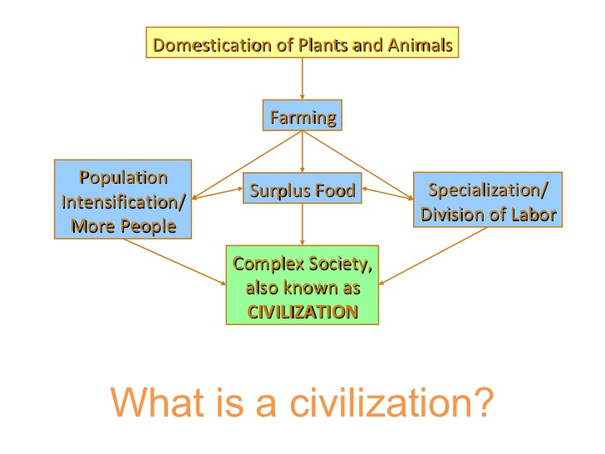

Cultural Diffusion Activity

# Cultural Diffusion & Its Limits

1. What are some reasons cultural diffusion stops spreading?

Look at the diagram and answer the questions.

Each triangle represents a civilization/culture.

E B

A F

C

D

E

1. Which civilization(s) do you think would have the most interaction? WHY?
2. Which civilization(s) do you think would have the least interaction? WHY?
3. Which civilization(s) do you think would change most? WHY?
4. Change the Least? WHY?

Check for Understanding…Agricultural Revolution

**Look at the chart below and explain HOW the domestication of plants and animals eventually lead to the birth of civilizations. You must provide at least THREE connections or links between domestication and civilizations. In other words, HOW did civilizations develop as a result of domestication.**



_________________________________________________________________

_________________________________________________________________

_________________________________________________________________

________________________________________________________________

_________________________________________________________________

_________________________________________________________________

_________________________________________________________________

Check for Understanding…Cultural Diffusion

Read the passage below and answer the question that follows.

***"The continent of Australia was once inhabited by aborigines, natives of the continent. Over time, the continent was used by Europeans as a place to put their prisoners. Today most of the present-day Australian people represent the European culture. "***

**In CSET explain the following…**

**WHY do you think Australia has a large segment of people who share the European Culture? Underline your evidence.**

_________________________________________________________________

_________________________________________________________________

_________________________________________________________________

________________________________________________________________

_________________________________________________________________

_________________________________________________________________

_________________________________________________________________

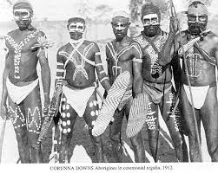 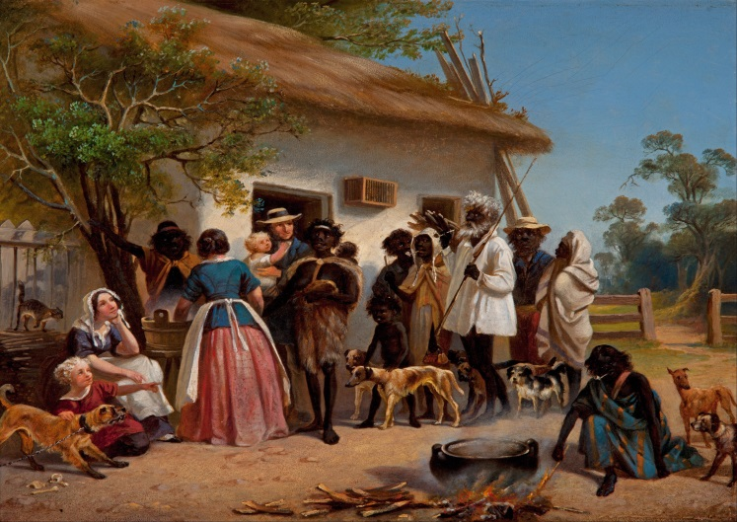

Check for Understanding

In **CSET** answer the following question:

How does Site/Situation impact communication, transportation and accessibility?

Cite at least three examples to support your answer.

_______________________________________________________________________

_______________________________________________________________________

_______________________________________________________________________

_______________________________________________________________________

_______________________________________________________________________

_______________________________________________________________________

_______________________________________________________________________

_______________________________________________________________________

_______________________________________________________________________

_______________________________________________________________________

_______________________________________________________________________

_______________________________________________________________________

_______________________________________________________________________

_______________________________________________________________________

_______________________________________________________________________

Skill Check for Understanding…

**Below are maps of Boston, Massachusetts. Based on the reading of Site & Situation, explain WHY early Europeans chose to settle in Boston. Place your answer in Box #1.**

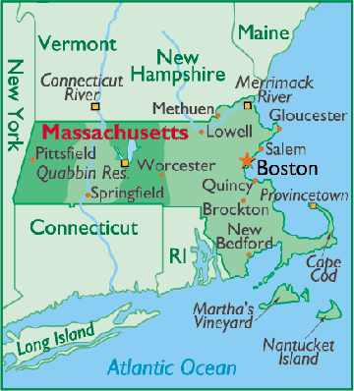 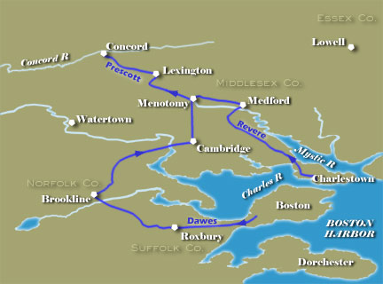

**Boston**

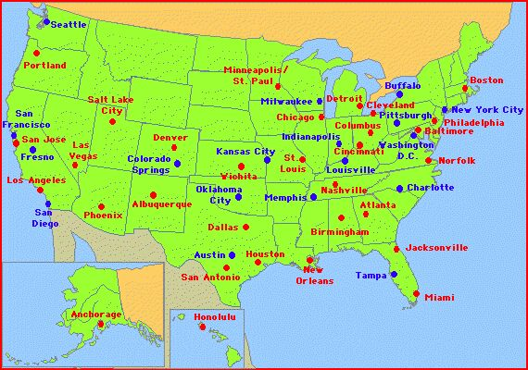

Box #1 ______________________________________________________________

__________________________________________________________________________________________________________________________________________

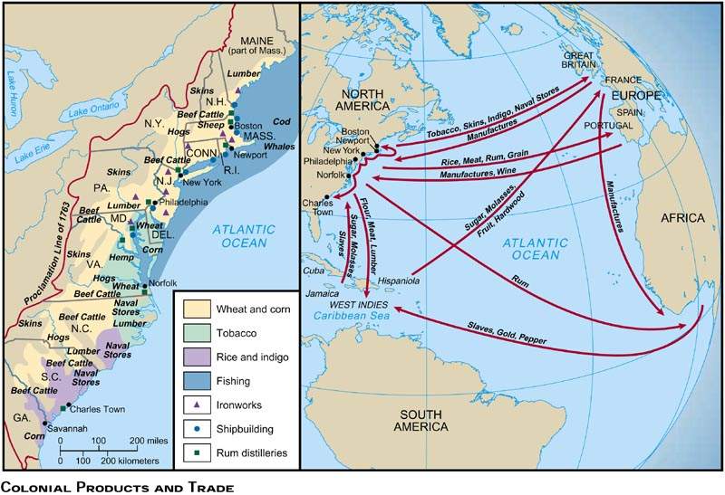

Using the maps above, explain how Boston’s SITUATION helped it develop into a major city.

_____________________________________________________________________________________________________________________________________________________________________________________________________________________________________________________________________________________________________________________________________________________________________________________________________________________________________________________________________________________________________________________________________________

The Kingdom of Bhutan…Activity

The Kingdom of Bhutan is a small Himalayan country east of Nepal, nestled between China and India, with an estimated population of 700,000. The deeply traditional nation has been slow to adopt modern development for a number of reasons. Aside from its **site & situation** a country-wide ban on television and the Internet was only lifted in 1999, and only after the previous king abdicated power in 2006 did the nation have its first parliamentary elections. Bhutan, often rated as one of the happiest countries in the world, is the birthplace of the concept of "gross national happiness," an alternative to the more traditional measure of gross domestic product. The popular Oxford-educated king is now seeking to strengthen ties with other nations while preserving as much of Bhutan's independence and culture as possible. Collected here are recent images of people and places within the Kingdom of Bhutan.

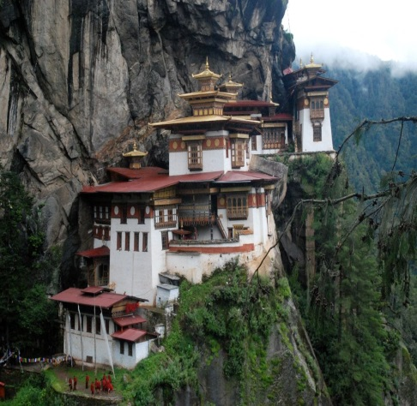 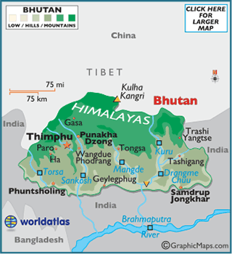 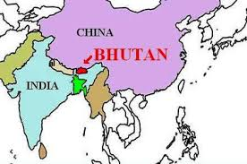

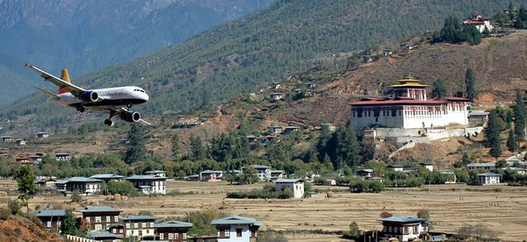 How will lifting the ban on technology change this region? Explain.

___________________________________________________

___________________________________________________

___________________________________________________

___________________________________________________

___________________________________________________

___________________________________________________

Describe Bhutan's Site & Situation. How has its Situation prevented it from trade, communication and travel? How do you know this?

(INFERENCE- You must use background knowledge from the last unit.)

_______________________________________________________________________________________________________________________________________________________________________________________________________________________________________________________________________________________________________________________________

Check for Understanding: Characteristics of Civilizations

In CSET…

List & explain three elements of civilizations then explain where most early civilizations began listing three reasons why they began there.

_________________________________________________________________

_________________________________________________________________

_________________________________________________________________

________________________________________________________________

_________________________________________________________________

_________________________________________________________________

_________________________________________________________________