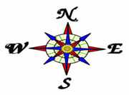Building Global Mental Maps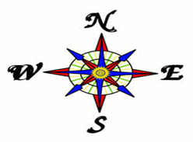
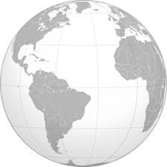
Introduction to Maps
Geography Standard One 6-8a: Students will demonstrate mental maps of the world and its sub-regions which include the relative location and characteristics of major physical features, political divisions, and human settlements.

Essential Questions:
Why does where matter?
To what extent are mental maps of different scales linked?
To what extent are human settlements connected?
Student Resource Packet
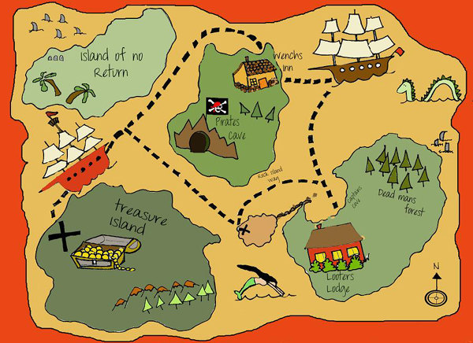
Name: _____________________
Fall 2014
PD: ___

Geography Standard 1A: Mrs. Bole

Lesson 1
Basic Geography: Mental Maps
Making a mental map is a very important skill. You never know when you're going to need to visualize a place or a location in your head.
First of all, what is a mental map? It's a drawing of something that you see only in your head.
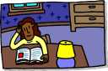
For example, what does your room at home look like? Can you see it in your head? Can you describe it without drawing it? Where is your bed? What else is in your room? Where are those things in relation to the bed?
When you can see these things in your head, you have taken the first step toward making a mental map. Now, you can draw a picture of your room in your head and see where different things are.
In this box, draw a picture of your room.

Why do you need mental maps? You might not always have a map with you. If you want to tell your friend how to get to your house after school, you can visualize how to get there and tell him or her which streets to take to get from school to your house.
What does visualize mean?

Take two minutes to draw a mental map of the way you would drive to the Dover Mall from Postlethwait. Then, using your own mental map, explain to your table partner how you would get there.

Did you and your partner have the exact same mental map? Explain below.

Explain why they might have been different.

Mental maps also tell us how much of our surrounding we remember just by thinking about them. For example, you probably know a lot about what's outside your home or who lives in your neighborhood. You probably know what color your neighbors' houses are (at least some of them), and you surely know how to get from school to home and back. You know a lot about where you live because you've been there many times.
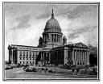
But what about your state capital? How many times have you been there? What about some other place that you've been to only once? You might find that your mental map of that place has fewer details than the one you can draw of your room, your house, or your neighborhood.
This illustrates the need to really pay attention to your surroundings, another skill needed in the study and practice of geography.

WHY are some mental maps more detailed than others? Cite specific evidence from the text to support your answer! (You may use highlighters to help!)
________________________________________________________________________________________________________________________________________________________________________________________________________________________________________________________________________________________________________________________________________________________________________________________________________________________________________________________________________________________________________________________________________________________________________________________________________________________________________________________

When you finish, please turn to page 47 and complete Mental Map #1: Delaware. You may use your atlas if needed.

The 411 on Maps…
What everyone needs to know!
For an introduction to Map Essentials please see: http://www.youtube.com/watch?v=E5ltL5J85cY

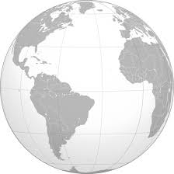
Maps are graphic representations of places that use point, line, and area symbols, as well as color, to show how selected human and physical features are located, arranged, distributed, and related to one another. No single map can show everything, so the features portrayed on each map are selected to fit a particular purpose. It is impossible to accurately depict (show, represent) the spherical Earth on a flat surface without distorting (changing) shape, area, distance, or direction (try peeling an orange and flattening it out!), so cartographers use different projections to preserve selected properties (shape, size, distance, direction), while others get distorted.
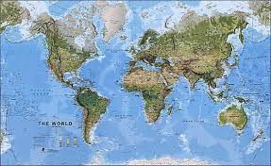
Map: A graphic representation of selected characteristics of a place, usually drawn to scale on a flat
An easy way to remember what every map should have…
TODALS
Title | What? Where?
Orientation | Compass Rose:  Direction. Which way is North?
Date | WHEN was the map made
Author | WHO made the map?
Legend | What the SYMBOLS mean
Scale | What is the distance between two points on the map?

surface.

Cartographer: A person who makes maps.

Map projection: The process of transferring information from a three-dimensional (spherical) surface to a two-dimensional (flat) surface. Every map has some distortion, either in shape, size (area), distance, or direction

Map Elements…What every GOOD map should have!
A good map should tell you what it is about (title), which direction north is (orientation), when the map was made or updated (date), who made the map (author), what the symbols mean (legend or key), how distances on the map relate to distances on the ground (scale), where to find selected places on the map (index), how to find places on the map (grid), and where the map's information comes from (sources or credits).
After you finish reading about TODALS, create a wordle to describe the elements.

However, not every map will identify all of this information. The more information provided, the better you will be able to evaluate its content, credibility, and appropriateness for a given purpose or audience.
You may have heard the acronym TODALS, which lists the map elements in order of
importance: Title, Orientation, Date, Author, Legend, Scale.

Station #1: The Title
TITLE: the title should be in a large font, easily identifiable as the title of the map and should include descriptive text as to the location and purpose of the map. If the map is thematic, the theme should be included in the title. For example: Corn Production in Washington, 1990. The title is usually the largest font size of all lettering on the layout, however, it should not dominate the map graphic itself. The title may or may not be in a box and does not need to be at the top of the page (though it often is). For published materials (e.g., books or articles) the title may be included in a figure caption instead.
See the examples below:
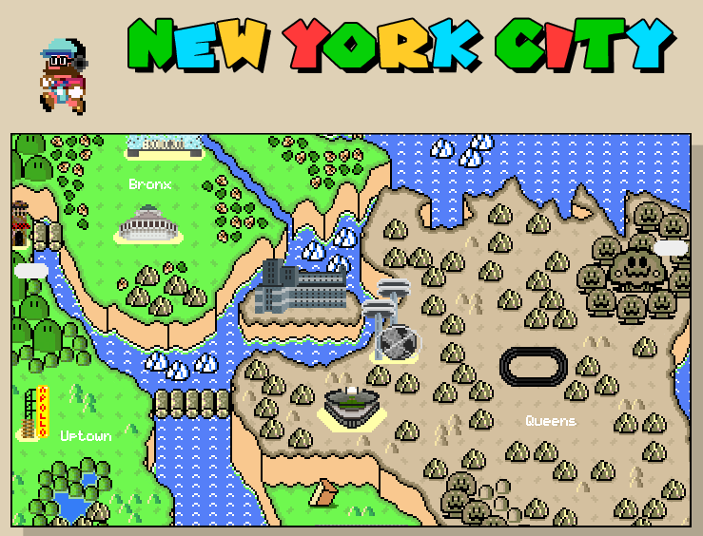
The map to the left is of New
York City. The Title has been
circled.

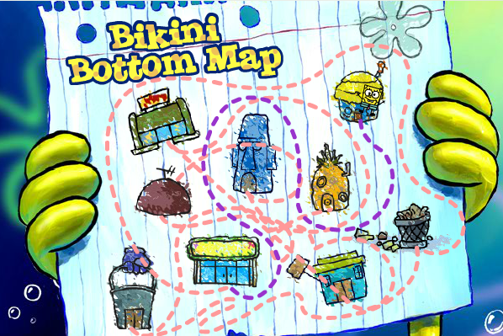
Look at Maps A & B. What is the Title of each?
Circle the title AND explain HOW you knew it was the title.
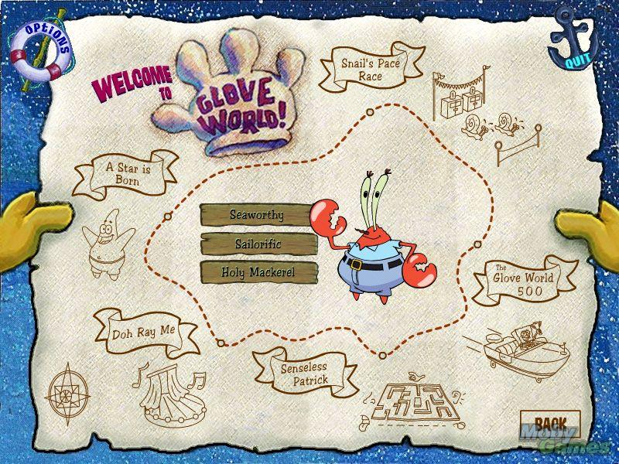
Map A Title: ____________________ Map B Title: ______________________
______________________________ ________________________________
How do you know?_________________ How do you know?___________________

Station #2: Orientation: The Compass Rose…
See Earthworm’s Geography Journeys!

Draw your compass rose in this box.

Make a Wordle to represent Orientation.

Station #3: The Date of the map!
Date: Text identifying when the map was made and/or updated. When was it written?

The date of the map is extremely important so that the reader knows exactly when the map was created. Imagine living in Europe and learning about the United States for the first time. If you were to look at a map of the Thirteen Colonies and the date was missing you might not know that the United States is now made up of 50 states!
Look at the maps below and notice the dates. Answer the questions below.

The Thirteen Colonies circa 1776

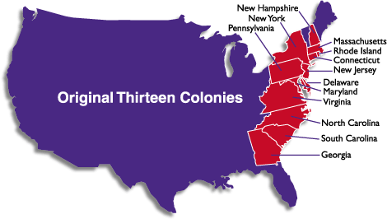
The year
the
map
represents.

A

United States circa 2000
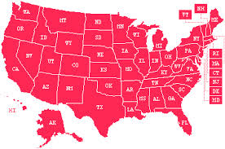

B

How are the maps different? __________________________________________________
WHY is the date important? ___________________________________________________
__________________________________________________________________________________________________________________________________________________

Compare and contrast the two maps below. Then answer the questions that follow.

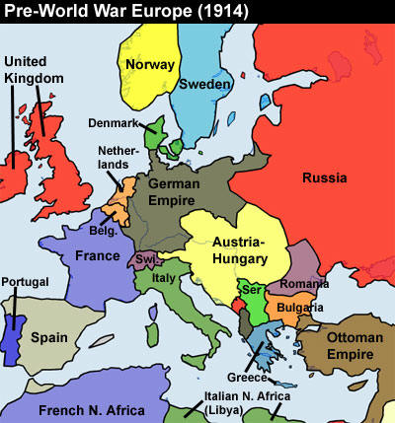
A

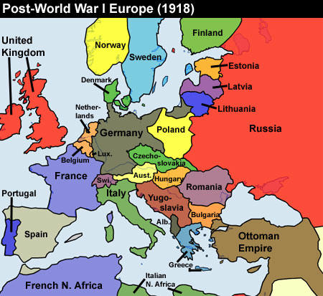
B

- What year does Map A represent? ______ What year does Map B represent? _________
- How do you know the year? _______________________________________________
- WHY is knowing the date of the map important? ________________________________
_______________________________________________________________________________________________________________________________________________________________________________________________________________

Station #4:

Extra! Extra! Read All About It!
The Author of a Map!
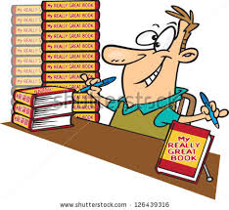

What is an author? An author by definition is a person who has written something; especially : a person who has written a book or who writes many books
a person who starts or creates something (such as a plan or idea)
a cartographer
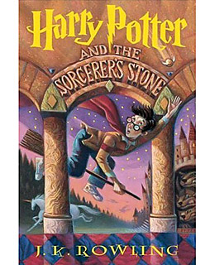
Example: the Harry Potter book to the right was written by J.K.Rowling. It shows that at the bottom of this book.
Cartographers are the authors of the maps that we read every day, the same as an author of a book.
The person in this picture is the cartographer or author of this map. Notice she is drawing the map and will be placing her name somewhere on the map!

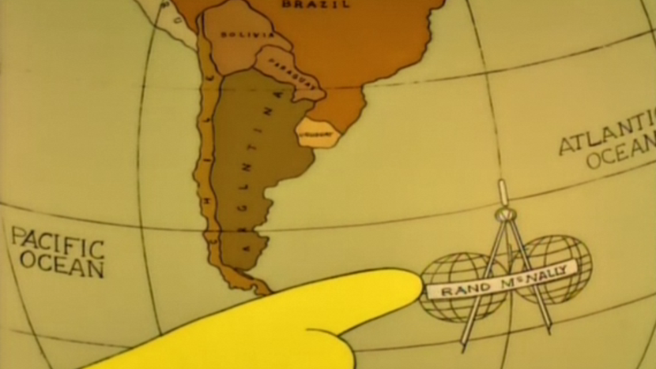
Scavenger Hunt…
Circle the author, cartographer, of each map below.
B
A

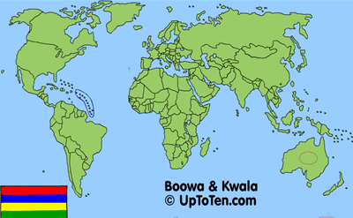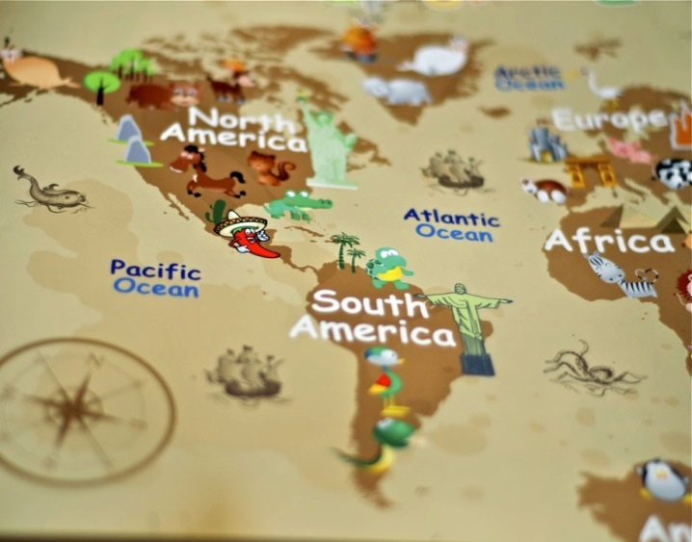
C
Maps4Kids
2012

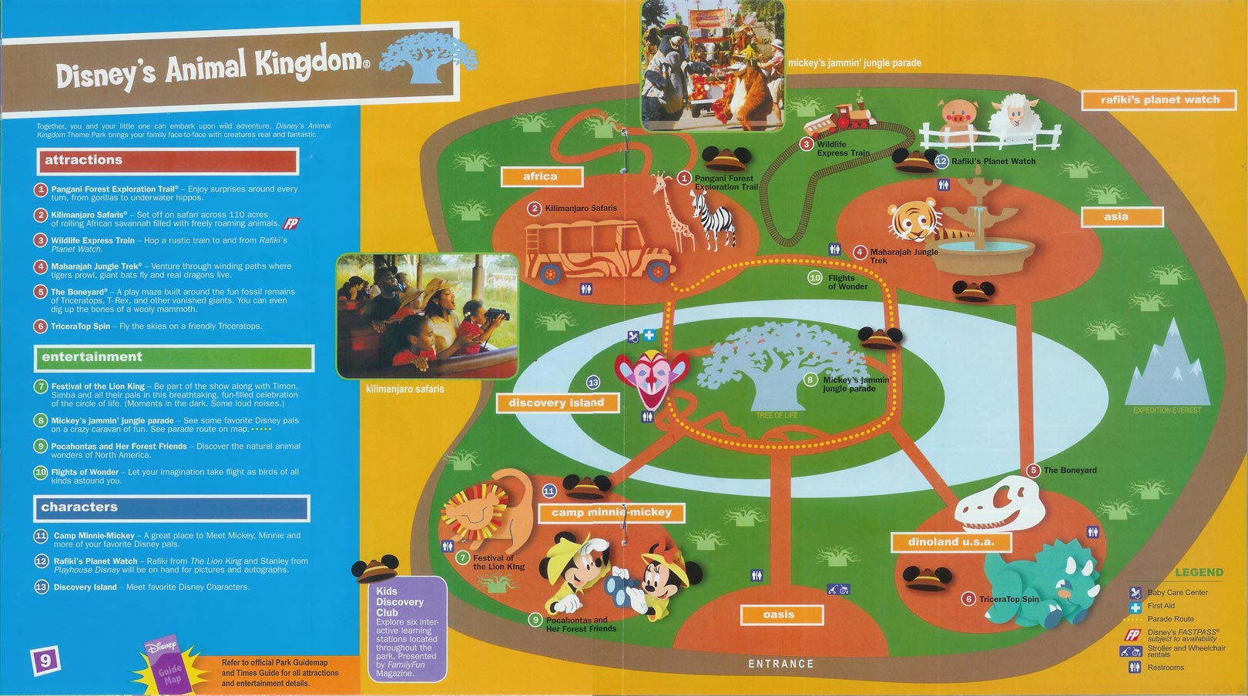
Walt Disney World
Maps

Station #5

The Legend…
Map | Legends
Maps give information by using symbols. Symbols can be figures, shapes, lines, and colors that show where places and things are on a map. A map's legend tells you what the symbols mean.

A map legend is a collection of symbols needed to read a map.
• A symbol is an object that represents something else.
• It can be a picture or a drawing, a shape, a letter, a colour or a number.
• On a map, all of the symbols are collected together to form the map legend.
• Use a sample map (i.e., provincial road map, community map, topographic map)A map legend is a collection of symbols needed to read a map.
• A symbol is an object that represents something else.
• It can be a picture or a drawing, a shape, a letter, a color or a number.
• The map legend is usually located at the bottom or on the side of the map.

Examples of Map Legends:
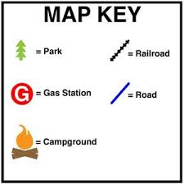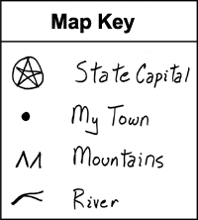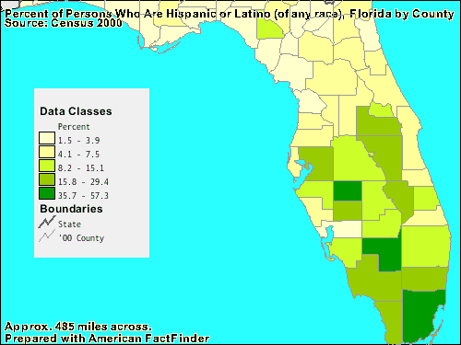
The Legend for this map is circled below.

Legend Activity….

Station #6: Map Scale 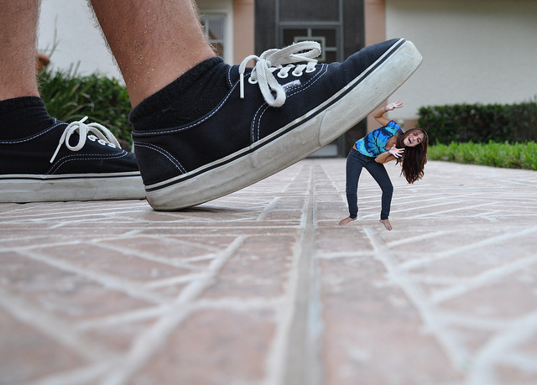
“Honey I shrunk the kids”
Look at the maps on your desk as well as the globe. All of them are realistic replicas of the world in which we live. Depending on which you are looking at, you will see the oceans, countries etc… all in their “relative location” as they appear from space. However, the actual size of the world, country, body of water has been “shrunk” so we could see it all.
Maps can show the actual shape of a place but they cannot show the actual size of a place. The size of a place must be reduced to fit on a piece of paper or a globe. To help us figure the actual distances, maps are drawn to scale. Scale is used to keep the shape of a place and show the distance. A map scale shows the relationship of the actual distance on Earth to the distance on the map.
Map scales often show distance in miles and kilometers. These are two units of length used to measure distance.
Watch the video below to help understand scale and answer the questions that follow.
- Are the kids the same shape as they were before they became smaller? _____
- Are the kids the same SIZE as they were before they became smaller? _____
- Would you agree that even though the kids are smaller they still look the same? ____
Why or why not?____________________________________________________
- Do you agree that even though the world is smaller on the map, it still looks about the same? ________ Why or why not? ______________________________________
https://www.youtube.com/watch?v=AMGZwxc9VqI
Complete the worksheet: Finding Distance in Libya on the next page.

Finding Distance in Libya

- How many symbols are in the Legend? ________ Circle the legend.
- Find the Compass Roses (orientation). Add the other directions to it.
- Put a check next to the scale.
- Using a ruler, how many miles are in an inch according to the scale? ___________
- How many kilometers are in an inch according to the scale?
- Use the map above to answer the questions below.
  - What is the capitol of Libya? ___________________________________
  - What is the approximate distance from
    - Hofrea to As Sidrah in miles? ____________ kilometers? _______
    - Oil Field #2 to As Sidrah in miles? _________kilometers? _______
    - Oil Field #4 to Ajdabiya in miles?__________ kilometers?_______
  - Which pipeline covers the longest distance? _______________________
  - Which pipeline covers the shortest distance? ______________________
- Drawing conclusions: Where do all the oil pipelines in Libya go? ______________
How do you know? ________________________________________________
- Making connections: Based on your answer to #7 above, why, do you think, all the oil pipelines go to that destination? Why would they NEED to go there? ________________________________________________________________________________________________________________________________________________________________________________________________________________________________________________________________________

Map Distortion 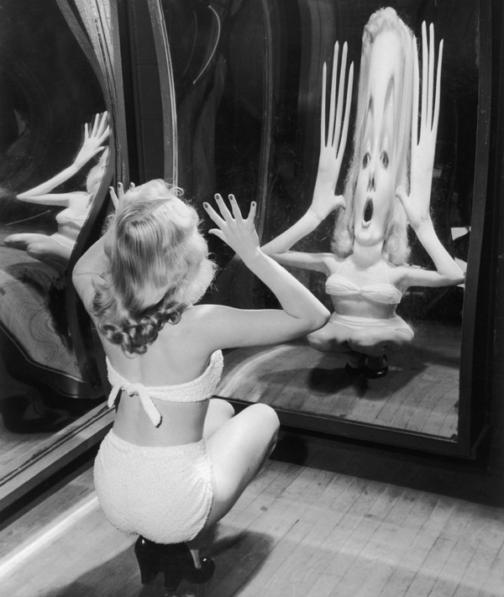
Lesson 2
Activity Page

- Define distort: ___________________________________________________________
_______________________________________________________________________
- Think.Pair.Share. Give a real life example of something that you can “distort” on maybe your DSI, or something else. _________________________________________________________________________
_________________________________________________________________________ _________________________________________________________________________
- Blow up a balloon at your table and tie it at the neck. Now draw it as you see it in the box below.

- Now, QUIETLY pop the balloon and tape it flat in the box below-tape ONLY the edges of the balloon.

- Answer the questions below:
- Does the balloon you drew in Question 3 look the same or different from the balloon you drew in Question 4? ____________ Explain why you think this is. _______________________
___________________________________________________________________
- What looks different about the balloon once it was popped? ________________________
- Were you able to get the balloon to lay perfectly flat on the paper? ___ Why not? _______ ______________________________________________________________________
- Do you think cartographers have a similar problem when trying to place the globe on a map? Yes or No? Explain why you think this. _________________________________________
______________________________________________________________________

- What do you think MIGHT change or become distorted when cartographers try to represent the world as a FLAT surface? _______________________________________________
______________________________________________________________________
- Now read the information on Maps VS Globes on page 18 and answer the questions below.
- What five (5) advantages does a globe have over a map?
1) ___________________________________________________________________
2) ___________________________________________________________________
3) ___________________________________________________________________
4) ___________________________________________________________________
5) ___________________________________________________________________
- If globes are so great, why aren’t they used all the time? List three reasons.
- ___________________________________________________________________
- ___________________________________________________________________
- ___________________________________________________________________
- What is a map? _________________________________________________________
- What are three advantages to using a map instead of a globe?
- ___________________________________________________________________
- ___________________________________________________________________
- ___________________________________________________________________
- What is a disadvantage of maps? ____________________________________________

Maps VS Globes
Globes and maps are used frequently in geography. To make the best possible maps and globes you need to understand how they relate to one another and what kind of information each can provide.
Globe A globe is the most accurate way to represent the earth’s surface. It is a scale model of the earth showing actual shapes, relative sizes and locations of landmasses and bodies of water. A globe also provides accurate information about distances and directions between two points. Globes, however, are very small representations of the earth. Even a large globe cannot show much detailed information. Also, globes are much more difficult to carry around and you can only look at one half of the globe at one time!
Map Maps are flat representations of the curved surface of the earth. Because they are flat they can be shown in a book. They can be folded up and used for planning a trip. They can show very large areas or very small areas. They are flexible tools that can show valuable information very efficiently. Maps are not as accurate as globes, however. To create a flat representation of the curved surface of the earth, something has to be distorted.

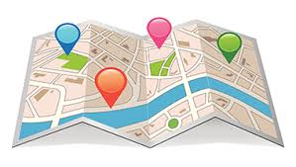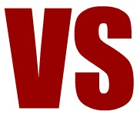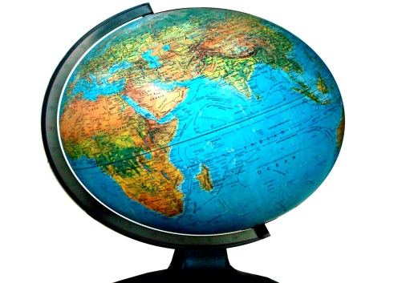

Map Projections: Reading
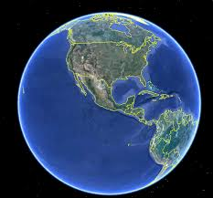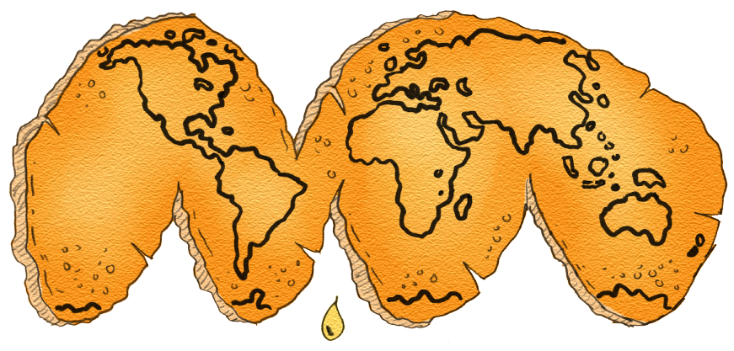
B
A
Since the Earth is a sphere, the most accurate model of the Earth is a globe. But often it is more useful to have a flat map of the Earth. Cartographers have made many flat maps of the Earth.
Making a flat map of the spherical Earth is not an easy task. To understand why, look at Figure A. Figure A shows the round earth (much like the shape of an orange). Now imagine peeling the curved surface of the orange (the skin) and forcing it to lie flat! To do this, you need to stretch and tear the orange AND make it lie flat. Figure B shows the results.
Look at the illustrations again. Notice how he shapes of the continents were changed when the curved peel was stretched flat. This change in a curved surface when it is flattened is called distortion. Every map of the Earth has distortion. Things on a map that can be distorted once a projection is made are: size and shape of continents as well as the distance between two points on the map. It is impossible to take a round object and flatten it completely without changing it in some way.
Different maps distort the Earth in different ways. Some maps distort the shape of continents. Other maps distort the size. The type of distortion a map has depends on its projection. A map projection is the way in which a cartographer projects, or shows, the curved surface of the Earth on a flat map. A cartographer chooses the type of projection to use based on the purpose of the map and what needs to be most accurate, or least distorted.
There are many different kinds of map projections that are used. A few of the most common projections are pictured on the top of the next page. Compare each projection with the globe and discuss it with your table partner.

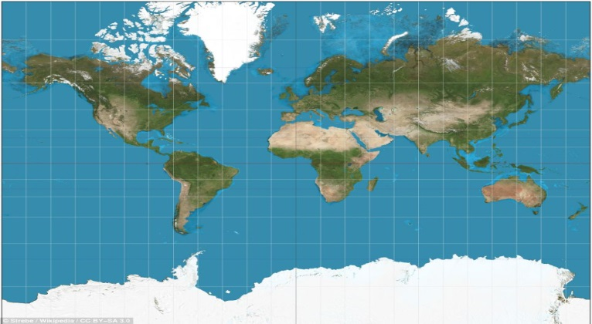

Figure A: the Globe Figure B: Mercator Projection
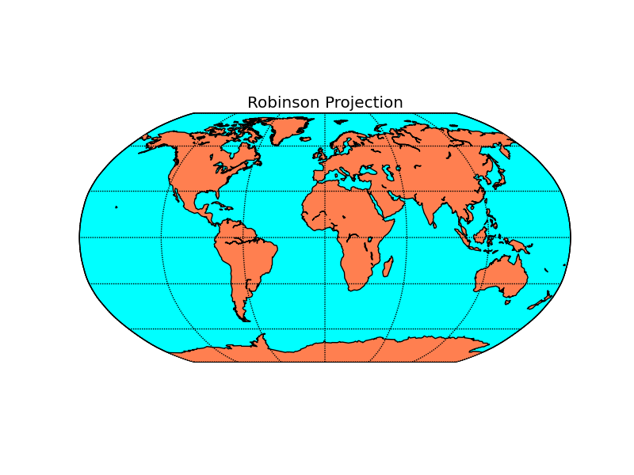
Figure C: Robinson Projection
Figure A is the Globe and is the most accurate representation of the Earth as it is round just like the Earth.
Figure B is called a Mercator Projection. It is named after Gerhardus Mercator, a Flemish cartographer who lived in the 1500s. The Mercator projection is one of the most common map projections. This type of projection does not distort the shapes of the continents but it does distort their size. This distortion increases as you move farther away from the equator. For example, Greenland looks as large as South America, but in reality South America is much larger than Greenland! This map is great for sailors traveling in the ocean. It allows them to know the direction they must travel to get from point A to point B with pretty good accuracy. Imagine having a map that has the size of the continents accurate but NOT the direction to get there! What problems do you think might happen if you were planning a trip from England to North America and the direction was not accurate? Write them in the box below.

Figure C is called a Robinson Projection. It is names after the American cartographer Arthur Robinson. This projection is becoming more popular. This projection, developed by Professor Arthur E. Robinson in 1963, attempts to create a visually appealing (or right-appearing) view of the entire world. Rather than trying to eliminate any single type of distortion, this is a compromise projection that attempts to keep all types of distortion to a minimum throughout the map area. In this projection, the world appears somewhat like an oval; however, the poles appear as lines rather than as points. The lines of latitude are straight and parallel and the lines of longitude are curved; however, they do not converge to a point.
Exit Ticket
3-Name three types of projections used to represent the earth.
2-Give two distortions of a Mercator Projection.
1-Give one reason Rand McNally wanted a Robinson Projection.
The development of the Robinson projection is unique in that it was a response to a request by a map and atlas production company (Rand McNally) to develop a better visual representation of the world for use in its publications. Not only is this projection still used extensively by Rand McNally, it has also been adopted by the National Geographic Society for use in many of the maps featured in its magazine and map products.
Which projection do you feel is best? Answer in CSET below.
Claim: The best way to represent the earth is by using a _____________________ projection.
Set up: I know this from reading through class notes.
Evidence: 1)______________________________________________
2) _____________________________________________
3)_____________________________________________
Tie In: ___________________________________________________
__________________________________________________________
__________________________________________________________

Political & Physical Boundaries A closer look at maps!
Lesson 3
Think.Pair.Share
How do you know you have gone from one neighborhood or town to another? _____________
_______________________________________________________________________
How do you know when you have left your town or city? _____________________________
_______________________________________________________________________
Towns, states and countries all have boundaries. Boundaries between countries are political boundaries. Some are determined using physical features like a mountain range or river.
Other boundaries may seem random, but somewhere a legal political body determined the boundaries.
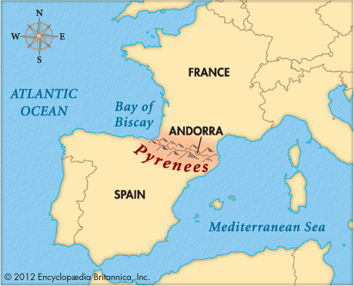
Physical Boundaries
The most obvious type of boundary is a physical boundary. A physical boundary is a naturally occurring barrier between two areas. Rivers, mountain ranges, oceans, and deserts can all serve as physical boundaries. Many times, political boundaries between countries or states form along physical boundaries. For example, the boundary between France and Spain follows the peaks of the Pyrenees Mountains, while the Alps separate France from Italy.
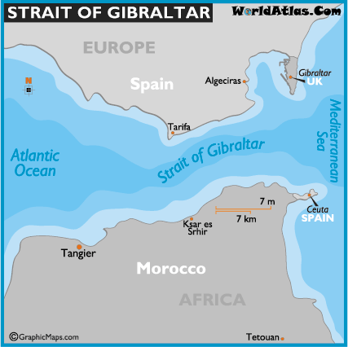
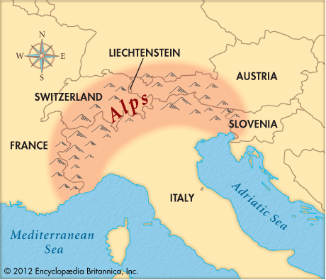
The Strait of Gibraltar is the boundary between southwestern Europe and northwestern Africa. This narrow waterway between the Atlantic Ocean and the Mediterranean Sea is an important political, economic and social boundary between the continents. Rivers are common boundaries between nations, states and smaller political units such as counties. The Rio Grande forms a large part of the boundary between Mexico and the US. The Mississippi River is the defining boundary between many of the states it winds through, including Iowa and Illinois, Arkansas and Tennessee and Louisiana and Mississippi.
Strait of Gibraltar
Alps
Political boundaries are the dividing lines between countries, states, provinces, counties, and cities. These lines, more often called borders, are created by people to separate areas governed by different groups. Sometimes, political boundaries follow physical boundaries, but most of the time you can’t see them. Most maps show political boundaries.

Political boundaries change over time through wars, treaties, and trade. After World War II, the map of Europe was almost completely redrawn. Germany’s eastern border was moved farther west, and the country itself was later divided into East and West Germany.
In 1803, the United States bought 2,147,000 square kilometers (828,800 square miles) of land in a treaty with France. This land, the Louisiana Purchase, expanded the size of the U.S. to include the areas that are now Arkansas, Missouri, Iowa, Oklahoma, Kansas, Nebraska, and parts of Minnesota, North and South Dakota, New Mexico, Montana, Wyoming, Colorado, and Louisiana. The western boundary of the U.S. moved from the Mississippi River to what is now Yellowstone National Park.
An important type of political boundary in the United States is the boundary of a congressional district. A congressional district is an area that elects a representative to the U.S. House of Representatives. After the U.S. Census, which is taken every 10 years, the population of a state may grow or shrink enough to gain or lose a representative in the House. When this happens, congressional district lines are redrawn in a complicated and controversial process called redistricting. The boundaries between congressional districts may unite or divide economic, social, or ethnic neighborhoods.
Political Boundaries
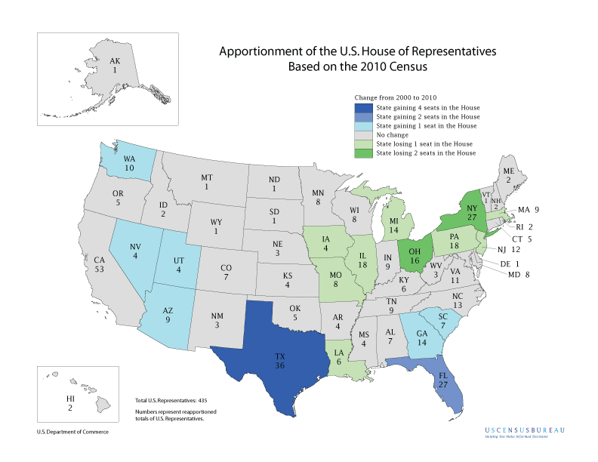
- What is a physical boundary? _________________________________________________________
- List four types of physical boundaries.
  - ___________________ c. ____________________________
  - ____________________ d. ____________________________
- What are three examples of physical boundaries from the reading?
- ________________________ c. _____________________________
- Can you think of at least two other physical boundaries in Delaware, the US or the World?
Write them on the space below.
___________________________ ___________________________
- How are political boundaries created? _______________________________________
- Can political boundaries be seen? ___________________________________________
- Can political boundaries change? ________ Give an example from the text. (Highlight the information in the text.) _________________________________________________
____________________________________________________________________
- What problems that might occur if a river was used as a boundary between two countries? ____________________________________________________________________
____________________________________________________________________

Exit Ticket:
3 Reasons Political Boundaries Change
2 types of Boundaries
1 example of a political boundary and 1 example of a physical boundary.

Physical Features & Human Settlements
Lesson 4
Introduction to Human Settlements
Directions: Using your “mental map” of the world answer the questions to the best of your ability. (Some of these questions might be a little “challenging” but give it your best try!) Good luck! We will be going over it together.
- You are sitting in your family room playing the Xbox and your mother asks you…
  - to put glasses of water on the table for dinner. You don’t have any bottled water in the house. Where do you go to get it? ____________Where do you think you would have gone to get water in the 1640s? _________ Why? ____________________________
___________________________________________________________________
- After dinner your mother asks you to wash the dishes.
  - How do you do that? ______ Where do you go? __________ Where do you think you would have gone to wash the dishes in the 1640s? ________Why? ________________
___________________________________________________________________
- Now that your dishes are clean you need to take a bath.
  - Where do you go? _____________Where do you think you would have gone to take a bath in the 1640s? __________Why? ____________________________________
__________________________________________________________________
- Look at the map of the early settlement New Sweden around the year 1640 below and answer the questions that follow. REMEMBER THE YEAR IS 1640!
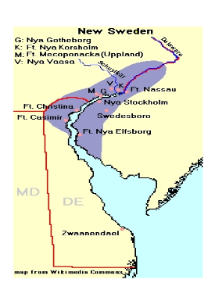

1. Along what landform (physical feature) did most people settle? ________________________
2. Looking at the landform where they settled, why do you think they settled there?
___________________________________________
3. How do you think the river helped the early settlers? For what jobs could they use it?
Delaware River
______________________________________________
= Settlements

- It is now the year 1859. In the name of Manifest Destiny the US government has just passed the Homestead Act encouraging Americans to settle west of the Mississippi River. You can keep the land you settle as long as you can grow crops on it for three years.
  - What type of land are you going to settle? _________________What landform will it be near? __________ Why? _______________________________________________
  - What landform(s) are you going to stay away from? ________________In other words, what physical features do you NOT want to settle and why? ______________________
- Complete the chart below.

Landform | Pro (How settlers could us it) | Con (Why they wouldn’t want to use it)
Rivers
Lakes
Grasslands
Mountain Ranges
Rainforests
Deserts
- Based on the answers to your questions above, what can you conclude about early settlers and “water”? (rivers, lakes, streams etc…) ____________________________________________
_________________________________________________________________________
- What is a physical feature? ____________________________________________________
- Geographers agree that there is a relationship between physical features (landforms such as rivers, mountains, lakes etc…) and where people lived long ago.
  - What do you think that is? In other words, why did people live where they lived? ______
___________________________________________________________________
  - What did they want to live near? __________________________________________
  - What didn’t they want to live near? ___________ Why not? _____________________
___________________________________________________________________
- On a separate paper draw your new “mental map” of the world. Include as many rivers, deserts, grasslands, rainforests, cities and lakes that you can. Out of the 75 that you placed on your 3D maps, how many did you remember?

Reference Pages/Homework Assignments
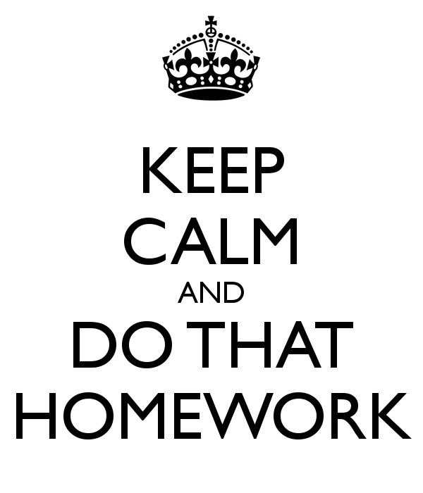
Name:_______________________________________________
Fall 2014
Period:__________

Vocabulary Word Bank Geography Standard 1A
Each time you learn a new word, please write it below along with the definition.
Word | Meaning

Geography Scavenger Hunt
Directions: Use the Atlas on your desk to complete the answers. You can look on ANY pages you want and will need to go through the entire Atlas! They go IN ORDER. Good Luck!
- List the five (5) oceans.
- List the seven (7) continents.
- Which continent has more deserts than forests and crop land?
- If it is 7:00 pm in New York, what time is it in Anchorage, Alaska?
- How many hours difference it there between Dover, Delaware and Paris, France?
- Where is the International Date Line located?
- Greenland is part of what continent?
- Identify the national capital of each of the following countries:
  - USA
  - Mexico
  - Canada
- What is the largest of the Great Lakes?
- What are the two mountain ranges in North America?
- In which ocean are the Hawaiian Islands located?
- Identify the national capital of each of the following countries:
  - Cuba
  - Venezuela
  - Brazil
- What islands are found off the south-eastern part of South America?
- What four European countries lie partly within the Arctic Circle?
- What sea is located south of Florida? What body of water is located west of Florida?
- What mountain range separates Europe & Asia?
- What mountain range separates France & Spain?
- Identify the national capital of each of the following countries:
  - Spain
  - France
  - Poland
  - Egypt
- In which ocean is Madagascar located?
- What body of water separates
  - Japan from Asia?
  - Saudia Arabia from Africa
  - Europe from Africa
  - Iran from Saudia Arabia?
  - Russia from Alaska?
Name: _________________
Date:_______ PD:_______
#:_______
Lesson 4

Physical Features & Human Settlements: Check for understanding
Using the map below as a guide as well as the information you learned in Lesson 4 explain the relationship between physical features and human settlements. YOU MUST USE AT LEAST ONE EXAMPLE FROM THIS MAP IN YOUR RESPONSE AND PUT YOUR RESPONSE IN CSET. UNDERLINE/HIGHLIGHT THE EVIDENCE.
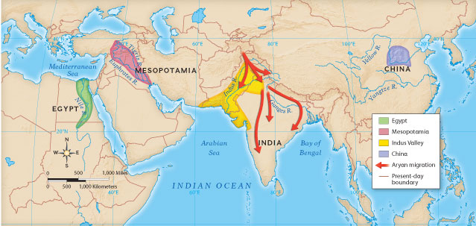

______________________________________________________________________________________

______________________________________________________________________________________

______________________________________________________________________________________

______________________________________________________________________________________

______________________________________________________________________________________

______________________________________________________________________________________

______________________________________________________________________________________

______________________________________________________________________________________

______________________________________________________________________________________
Name: ________________
Date: ________ PD: ___
#: _____

eastern Hemisphere Map
Please write in (if not already on the map) and label the map with the items listed in the box on the next page.
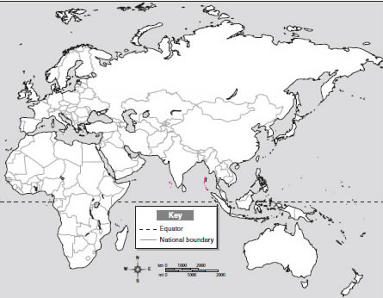
Eastern Hemisphere:
Rivers Grasslands
Danube (Europe) African Savannah
Murray (Australia) Eurasian Steppe
Volga (Europe) Australian Grassland
Yellow (Huang) Asia
Darling (Australia) Tropical Rainforests
Indus (Pakistan) Southeast Asia
Nile (Africa)
Ganges (Asia)
Congo (Africa)
Brahmaputra (Asia…India)
Mountains
Alps Himalaya Ural Great Divide Atlas
Lakes/Seas:
Caspian Sea Lake Victoria (Africa) Aral Sea
Lake Tanganyika (Africa)
Cities
Tokyo, Japan Seoul, Korea Mumbai, India Dehli, India
Shanghai, China Jakarta, Indonesia
Deserts
Gobi Kalahari Sahara Arabian Great Victoria

Western Hemisphere Map Informatio
Rivers
Mississippi Colorado Amazon Parana Paraguay
Mountains
Rocky Appalachian Andes
Lakes
Great Lakes Bear, Slave
Cities
Sao Paulo,Brazil New York City, NY Los Angeles, CA Mexico City, Mexico
Deserts
Great Basin/Sonora Atacama
Grasslands
Great Plains Canadian Prarie Mato Grosso
Tropical Rainforests
South America Central America

Western Hemisphere Map
Name: ________________
Date: ________ PD: ___ #:__________
Please write in (if not already on the map) and label the map with the items listed in the box on the previous page. 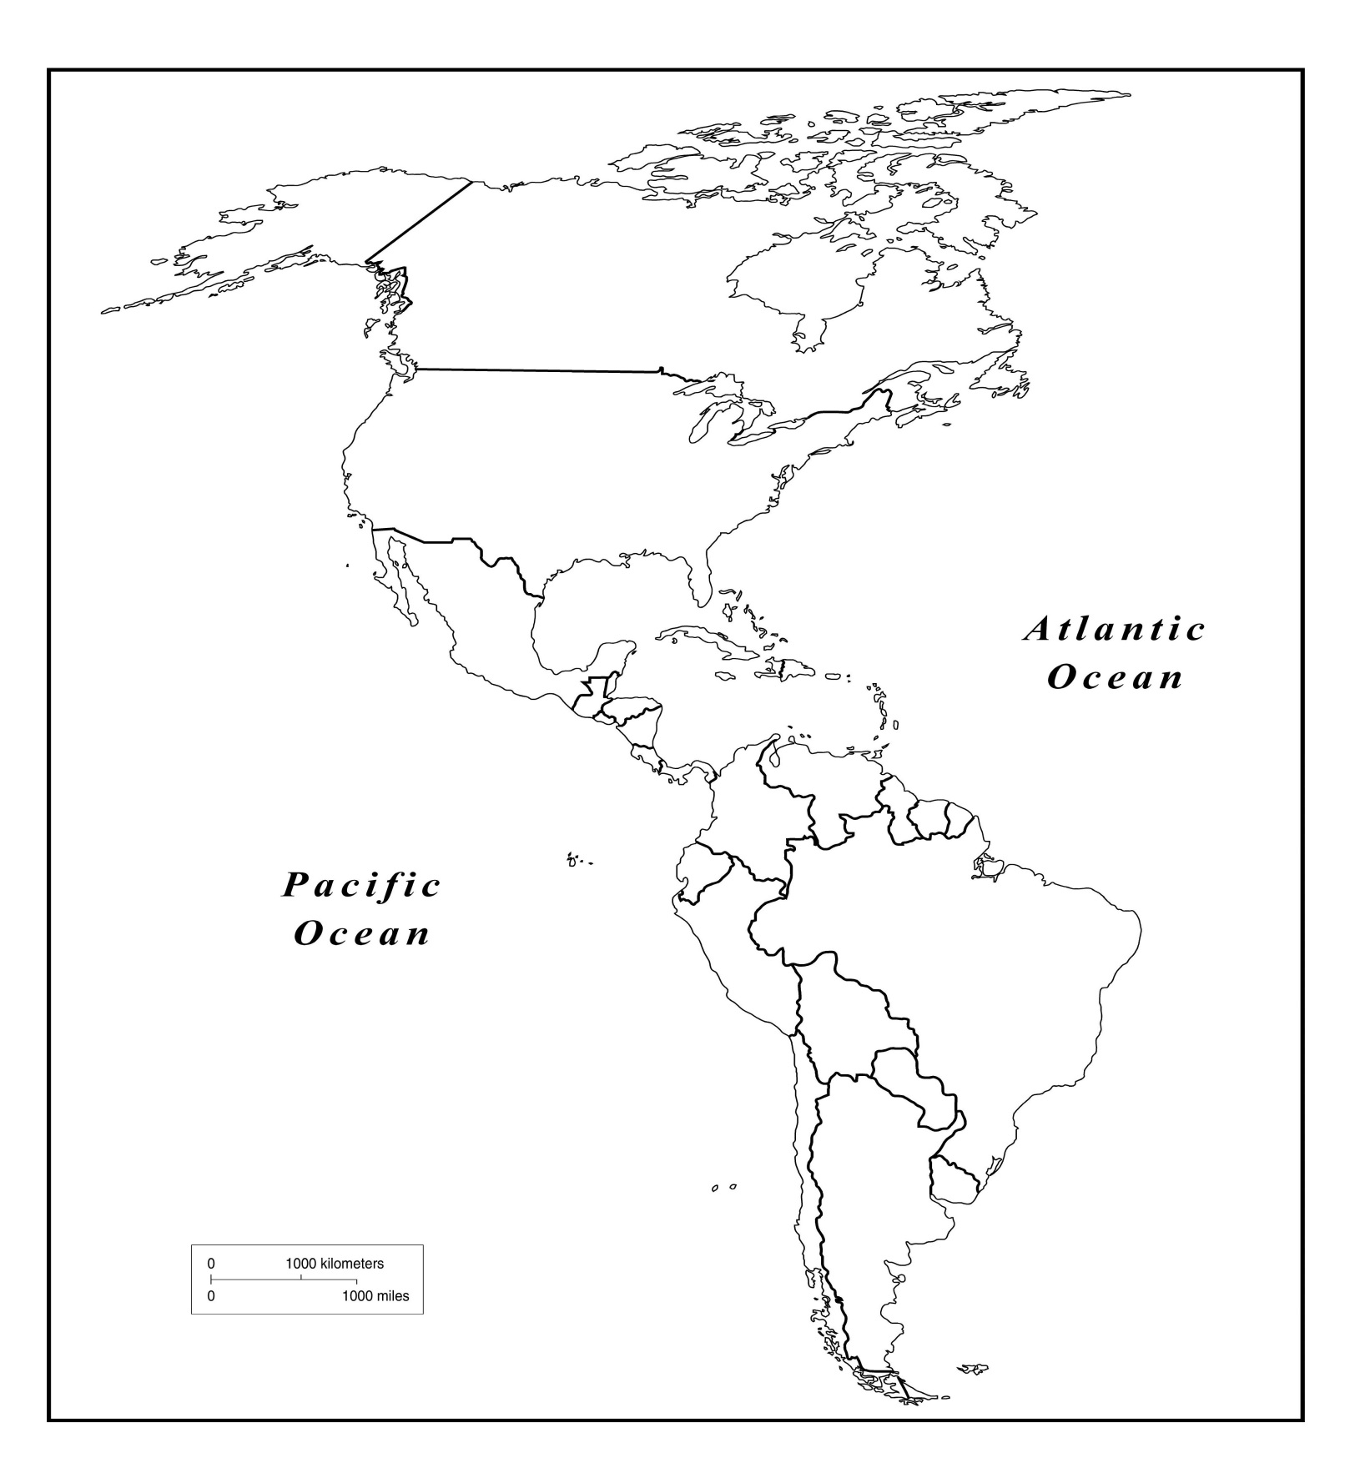

Australia Map
Name: ________________
Date: ________ PD: ___
#:_________
Score= /13
Please write in (if not already on the map) and label the map with the items listed in the box to the right.
Murray/Darling River
Australian Grassland
Great Divide
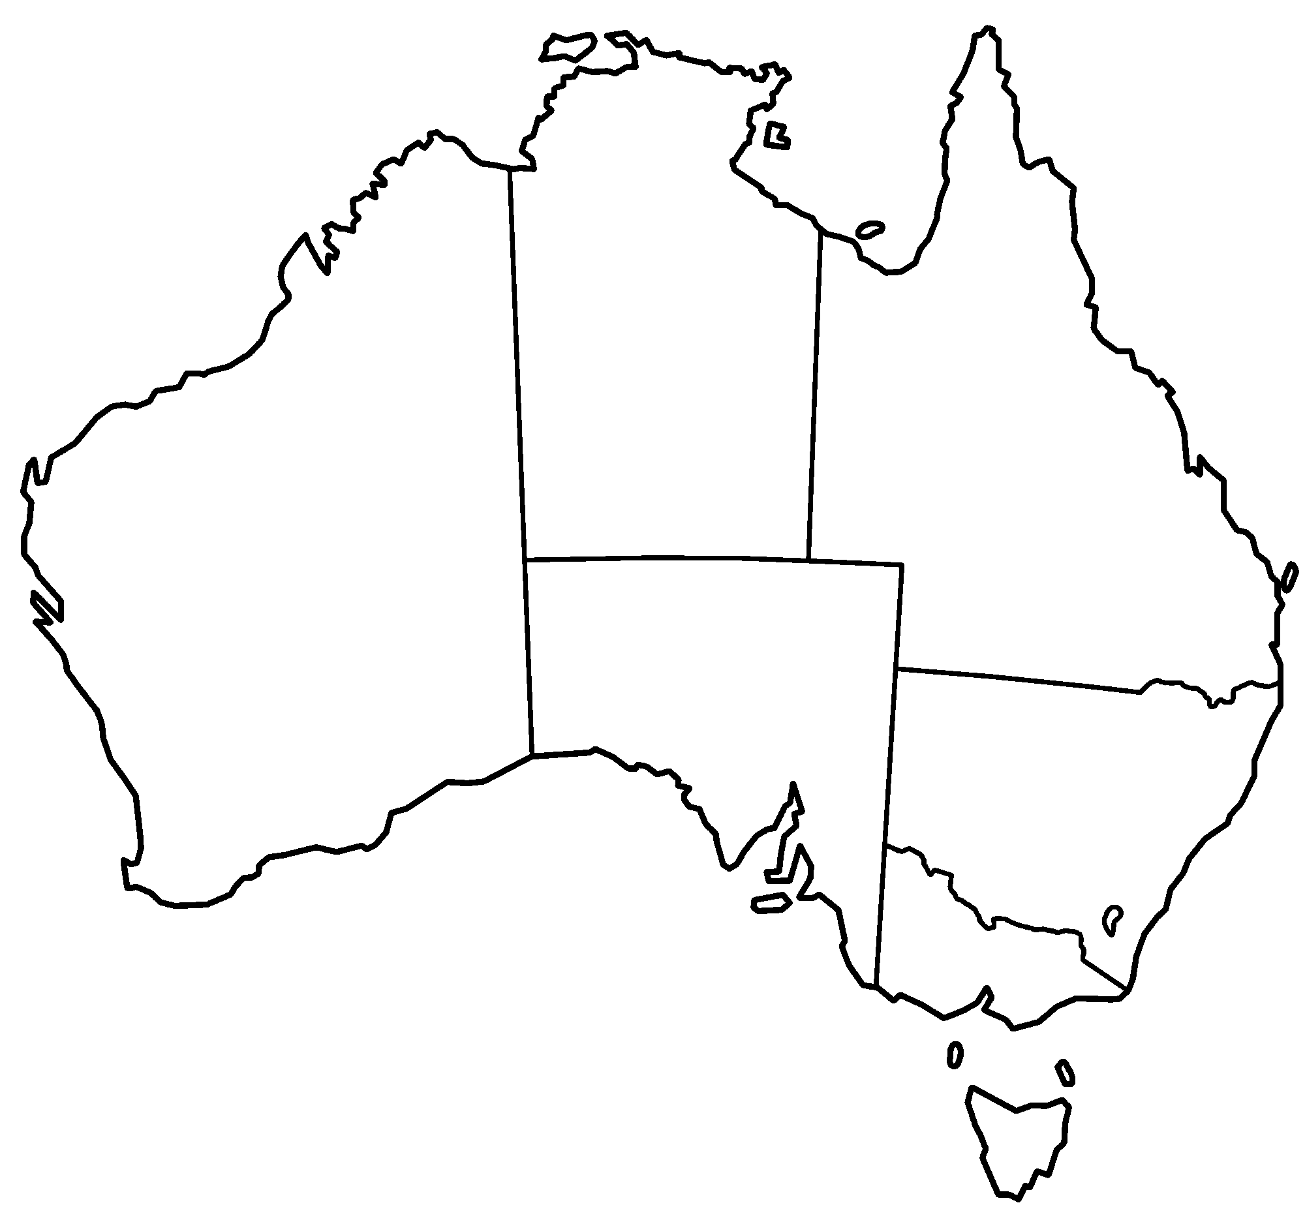

Asia Map
Name: ________________
Date: ________ PD: ___
#:___________
Score= /13
Please write in (if not already on the map) and label the map with the items listed in the box to the right.
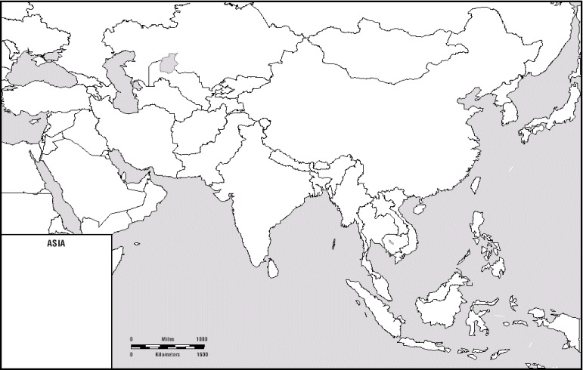
Ural Mts.

Himalayan Mts

Yellow (Huang) River

Eurasian Steppe

Mumbai, India

Seoul, Korea

Jakarta, Indonesia

Tokyo, Japan

Shanghai,China

Delhi, India

Persian Gulf

Indus River

Tropical Rainforests

Europe Map
Name: ________________
Date: ________ PD: ___
#:_________
Score= /4
Please write in (if not already on the map) and label the map with the items listed in the box to the right.
Danube River
Volga River
Alps Mt.
Ural Mts

Africa Map
Name: ________________
Date: ________ PD: ___
#:_________
Score= /8
Please write in (if not already on the map) and label the map with the items listed in the box to the right.
Atlas Mountains
Nile River
Congo River
Egypt
Madagascar
Lake Tanganyika
Sahara Desert
Kalahari Desert
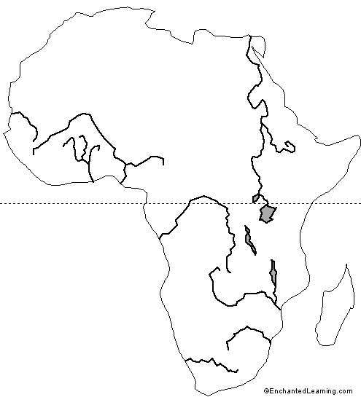

South America Map
Name: ________________
Date: ________ PD: ___
#:__________
Score= /6
Please write in (if not already on the map) and label the map with the items listed in the box to the right.

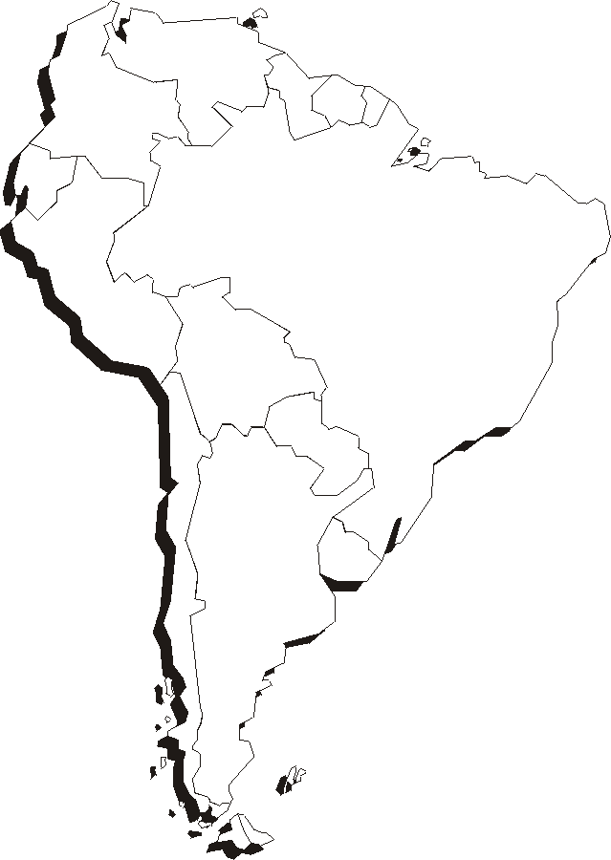
Amazon River
Andes Mountains
Parana River
Paraguay River
Sao
Paulo, Brazil

North America Map
Name: ________________
Date: ________ PD: ___
#:________
Score= /14
Please write in (if not already on the map) and label the map with the items listed in the box to the right.
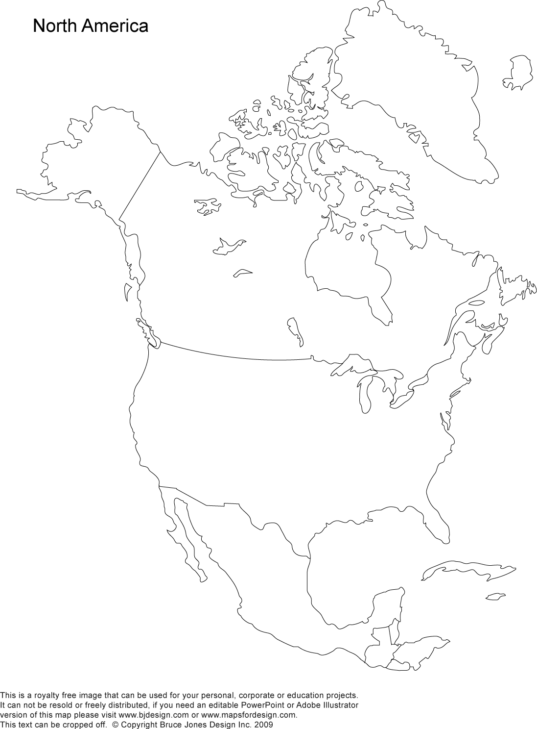
USA
Canada
Mexico
Rocky Mountains
Appalachian Mts
Great Bear Lake
Great Slave Lake
Great Plains
Mississippi River
Colorado River
Los Angeles
Mexico City
New York City
The Great Lakes

Name:________________
Date: ______ PD:________
#:_______

Physical and Political Boundaries: Check for Understanding
Lesson 3
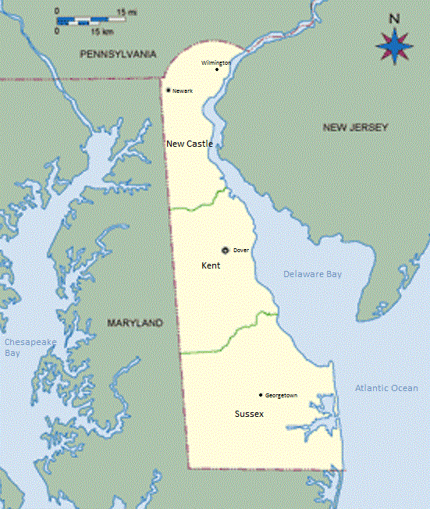
Looking at the map of Delaware, answer the questions.
1)Delaware has three Physical boundaries. List them:
a)_________________
b)_________________
Delaware River
c)_________________
Delaware Bay
2) How many counties does Delaware have?
New
Castle
Delaware River
___________________
3) Name the counties in Delaware.
___________________
___________________
___________________
Delaware Bay
Kent
4) Are the counties physical or political boundaries?________
How do you know?
_____________________
_____________________
_____________________
Atlantic Ocean
_____________________
Atlantic Ocean
_____________________
_____________________
Sussex
_____________________
Sussex

Weekly Map Practice #2: Western hemisphere

Weekly Map Practice #1: Continents, oceans, mountains, countries
Looking at the map provided, please fill in the information below.
A represents _____________________________ (a continent)
B represents ______________________________(a continent)
C represents______________________________(a continent)
D represents______________________________(a continent)
E represents ______________________________(a continent)
F represents______________________________(a continent)
F represents______________________________(a continent)
G represents______________________________(a continent)
H represents______________________________(an ocean)
I represents______________________________(an ocean)
J represents______________________________(an ocean)
K represents______________________________(an ocean)
L represents______________________________(an ocean)

1 represents ________________________________ mountains
2 represents_________________________________mountains
3 represents_________________________________mountains
4 represents ________________________________ mountains
5 represents_________________________________mountains
6 represents_________________________________mountains
7 represents_________________________________mountains
Word Bank
Asia Africa Australia Europe
N.America S. America
Antarctica Atlantic Pacific Indian Southern Arctic Atlas Rocky Appalachian Ural
Great Divide Himalayan Andes Brazil France Saudi Arabia
China Madagascar

The Symbols are COUNTRIES
Represents __________________________
Represents__________________________

Represents__________________________

Represents__________________________

Represents__________________________

Name:________________
Date: ______ PD:________
#:_______

Map Distortions: Check for Understanding
Lesson 2
Look at the Mercator Projection below and answer the questions that follow.

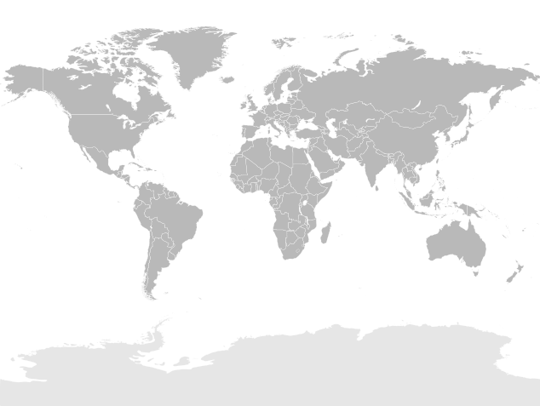
- Is this the most accurate representation of the earth? ___________ Support your answer with one fact. _________________________________________________________________________________
- What is one type of distortion that occurs on maps? ________________________________________
- Explain why distortions happen and provide AT LEAST one example. _________________________
_________________________________________________________________________________________________________________________________________________________________________________________________________________________________________________________________________________

TODALS Summarizing Activity (Check for Understanding)
Lesson 1
Using what you have learned, identify the TODALS on the map below. If there is anything missing on the map, please draw it in. Then, write in CSET what the map is showing.
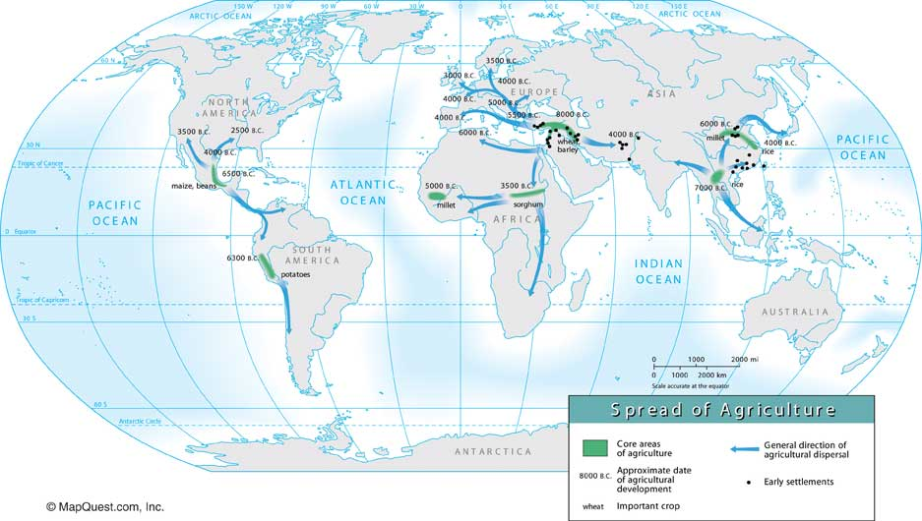

Claim: _______________________________________________________________________________________
Set Up: I know this from my social studies readings.
Evidence: ___________________________________________________________________________________
Tie-In (Conclusion):___________________________________________________________________________
Write your CSET on the lines below:
_________________________________________________________________________________________________________________________________________________________________________________________________________________________________________________________________________________________________________________________________________________________________________________________________________________________________________________________________________________________________________________________________________________________________________________________________________________________________________________________________________________________

Check for Understanding: Mental Mapping
Lesson 1
- What is a mental map?
- Explain why some of our personal mental maps are more detailed than others?
Put your answer in CSET below.
Claim: _______________________________________________________________________________________
Set Up: I know this from my social studies readings.
Evidence: ___________________________________________________________________________________
Tie-In (Conclusion):___________________________________________________________________________
Write your CSET on the lines below:
__________________________________________________________________________________________________
__________________________________________________________________________________________________
__________________________________________________________________________________________________
__________________________________________________________________________________________________
__________________________________________________________________________________________________
__________________________________________________________________________________________________
_________________________________________________________________________________________________
__________________________________________________________________________________________________
__________________________________________________________________________________________________
_________________________________________________________________________________________________

Mental Map 2: The United States
Directions: Using your MENTAL MAP try to complete as many of the following as you can. Then use an atlas to correct and complete your map. Write lightly in pencil so you can correct any mistakes. Put a check next to the direction as you complete and/or double check your answers on your map.

____Put a star where you think the Nation’s capital is located. What is the Nation’s capital?
____New York City is one of the world’s largest cities. Place an “NY” on the map where New York City is located.
____Chicago and Los Angeles are two other large cities in the United States. Place a “CHI” where Chicago is and a “LA” where Los Angeles is located.
____What is your favorite sports team? Place a tiny symbol/ball on the city where you think your favorite team plays.
____Can you find Lake Michigan on the map? Draw a small boat over Lake Michigan.
____Can you tell where the Mississippi River runs? Write the word “Mississippi” along the river where you think it is located.
____Where is the Gulf of Mexico? Can you label this body of water on the map?
____Label the Atlantic and Pacific oceans on the map.
____Label our neighbors, Mexico and Canada, on the map.
____There are two major mountain chains in the United States. They are the Rocky Mountains and the Appalachian Mountains. Write the word “Rocky” where you think the Rocky Mountains are and the word “Appalachian” where you think the Appalachian Mountains are.
____Place an “H” on a state that you would expect to be hot all year long.
____Place a “C” on a state that you would expect to be colder for a lot of the year.
____Place an “M” on a state which you think is hot during summer and cold during winter.

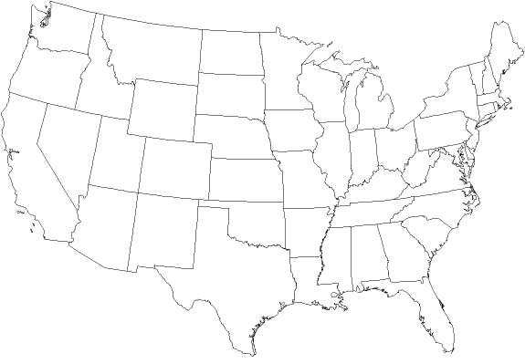
Mental Map 1: Delaware

Directions: Using your MENTAL MAP try to complete as many of the following as you can. Then use an atlas to correct and complete your map. Write lightly in pencil so you can correct any mistakes. Put a check next to the direction as you complete and/or double check your answers on your map.

Delaware has 3 counties. Can you label them? Put a “K” on Kent County, an “S” on Sussex County, and an “N” on New Castle County.
Place a star on the map where you think Dover, the capital of Delaware, is.
Place the letter “W” on the map where you think Wilmington, Delaware’s largest city, is.
A canal splits Delaware into two sections. Do you know what a canal is? Can you draw this canal onto the map of Delaware?
Place the letter “H” on the map where you think your house is located in Delaware.
Cape Henlopen is a popular state park in Delaware. Do you know what a cape is? Draw a circle around the area of Cape Henlopen.
Label the Delaware River, the Delaware Bay, and the Atlantic Ocean on the map.
If you wanted to go to the beach in Delaware, where would you go? Place the letter “B” on the spot where you think you would go to the beach.
Pretend you love to walk up and down hills. What part of Delaware has the most hills for you to walk on? Draw a hill onto the map where you would expect to find hills in Delaware.

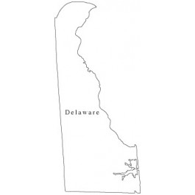

Continents & Oceans of the World

Directions: Label the seven continents and the five oceans on the map below. Please label directly on the map.

